**Unit 14: Choosing end life care and palliative care**

Exercise 5: The sequence in choice-making for palliative care

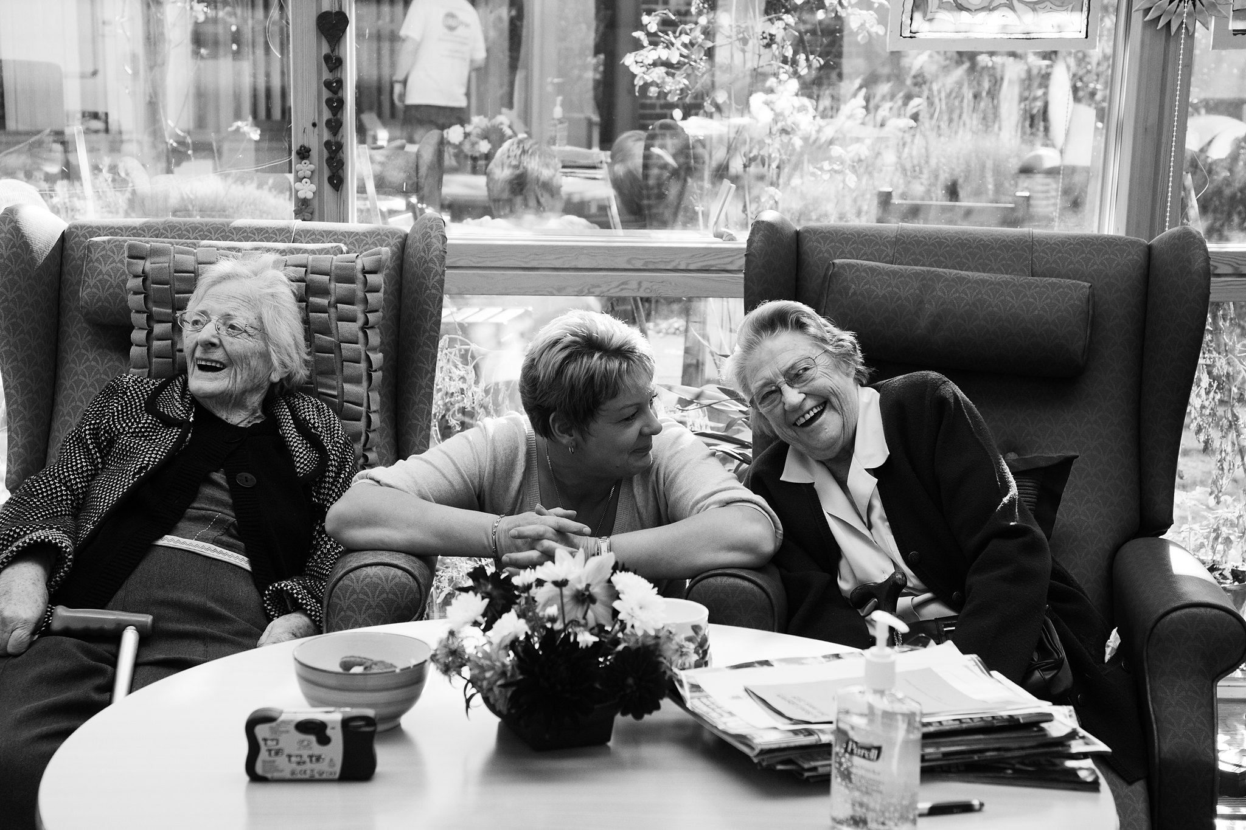

# Activity 1:

Choosing palliative care is not an easy task. You need to consider many different steps before you make a final choice. Worksheet 2 suggests 8 steps in the process of choosing palliative care. Activity focused on the process of choosing palliative care.

Steps:

1. AAWID receives 8 pieces of paper on which are written different steps of this process.

2. Then he should order them in the right sequence.

