**Unit 14: Choosing end life care and palliative care**

Exercise 3: Choosing the end-life and palliative care?

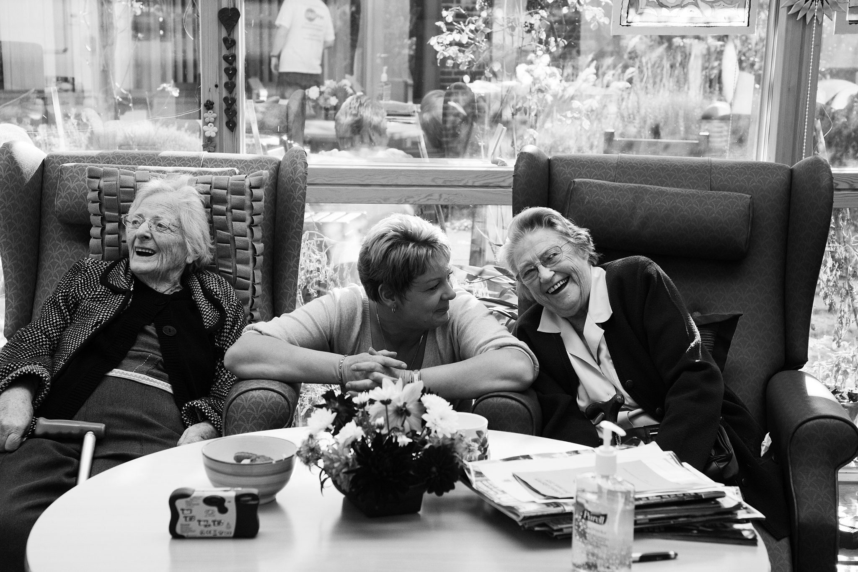

## Activity1: First steps to choose palliative care (Story & Quiz)

**Steps:**

**1.** AAWID should read the provided story;

**2.** Then should answer three questions with three possible answers each.

**Story – Chris chooses palliative care services Part I**

When Chris has felt that it is better to seek palliative care services for him his caregiver Isabel helped him a lot. She provided Chris with very useful information about what to start with first.Chris and Isabel found out together which are the providers of palliative care services in the region. Soon after this Chris visited his primary care doctor and asked him for a referral[[1]](#footnote-2). As Chris didn’t feel comfortable in his homeanymore, he was in a hurry to find a good hospice where he could feel better. Therefore it was important to find the hospice for which the waiting list was not very long. Happily, after 10 days of active searching, they have found a place in the outskirt of the same city where he lives. First, Chris and Isabel visited the hospice in order for Chris to see what is the environment as well as to meet the hospice team. He was pleased when he saw the convenient and well-equipped rooms, the beautiful flower garden, and a nice view of the nearest mountain. Other residents who Chris met there looked calm and well treated.After the visit, Chris had many questions before he makes his final choice.

1. What was the first step which Chris and Isabel did when choosing palliative care services?

|  |  |  |
| --- | --- | --- |
| businessman-examining-papers-table | A | They have completed all necessary application documents and submitted them. |
| C:\Users\Admin\AppData\Local\Microsoft\Windows\INetCache\Content.Word\114060-OOYHOE-336.jpg | B | They have tried to find out which are the PC services in the region where Chris lives. |
| young-female-doctor-with-clipboard-talking-cell-phone-white-background | C | They were waiting for the primary care doctor of Chris to call him and invite him for consultation. |

2. Why Chris has decided to visit the hospice beforehand?

|  |  |  |
| --- | --- | --- |
| hospital-room-with-bed-wheels-illustration_1262-16333 | A | Because he wanted to see the environment in the hospice, the rooms, as well as to meet the staff members. |
| 50531084568_c8143c9c3e_w | B | Because he wanted to check how far is the hospice from his home and whether his caregiver Isabel will be allowed to visit him. |
| C:\Users\Admin\AppData\Local\Microsoft\Windows\INetCache\Content.Word\elderly-male-does-know-what-kind-emotion-express.jpg | C | Chris didn’t want to visit the hospice as he was not sure whether this is allowed. |

|  |  |  |
| --- | --- | --- |
| C:\Users\Admin\AppData\Local\Microsoft\Windows\INetCache\Content.Word\50531084568_c8143c9c3e_w.jpg | A | He checked whether there is public transport to reach the hospice. |
| vector-illustration-retro-style-hand-giving-money-other-hand_1284-42589 | B | He checked what is the price of the palliative care service. |
| asian-young-main-group-hospital-professional | C | How many medical doctors work in the hospice? |

3. When Chris didn’t feel comfortable in his home anymore and start searching for a hospice, what he paid attention to?

1. The statement may need to be adapted in order to fit the country specific requirements for provision of palliative care [↑](#footnote-ref-2)