Unit 14: Choosing end life care and palliative care
Exercise 2: The patient as an active party in the palliative care

Chris is living in the hospice (story)

Chris is living in the hospice for a week already. He is feeling comfortable and the severe pain is now bearable. Despite the fact that the staff is taking good care of him, Chris still has some concerns related to his choice to be in the hospice. For example, he thinks about the costs of the PC service: he has to pay every month but for how long time he can afford this? He doesn’t want to bother his family with additional costs.
Gradually, he feels like he is losing his independence as he is accommodated in a hospice and the team is supporting him 24 hours per day. There are few things, which Chris still does on his own:
- He takes shower every morning;
- He chooses his meals between 2 options written in the lunch and dinner cards;
- He goes on a walk in the flower garden for 30` before noon, and every Sunday he meets his friends in the guest hall of the hospice.
Other activities like taking the prescribed medication, measuring the blood pressure, coping with pain, and doing exercises for rehabilitation are no longer the tasks for Chris. The medical team has responsibility for all of this.

Activity 1: How independent is Chris in the hospice? (quiz)
AAWID should read a story and then answer three questions with three possible answers each. This exercise ranges over the level of independence of hospice-services users and allows to educator to check the level of understanding of AAWID concerning independent living in the context of resident care.

1. What are the activities, which Chris still does on his own in the hospice?

 | A | Doing exercises & taking medication.
 | B | Going for a walk every day & meeting friends once per week.
 | C | Preparing the food & cleaning the room.

2. What are the activities which the medical team inthe hospice is responsible for?

 | A | Whether they will be enough medical specialists and doctors who can treat and support him.
 | B | Whether they will allow him to leave his hospice room.
 | C | Whether he will be able to pay his monthly bills for the hospice stay and for how long?
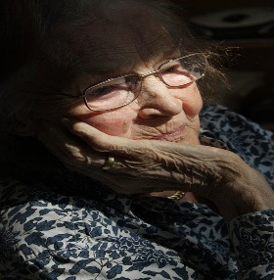 | A | Help Chris feel more comfortable and relieve his pain.
 | B | To help Chris in taking shower and eating.
 | C | To accompany him during the walk in the flower garden.

3. What are Chris’s concerns during his first week in the hospice?

