**Unit 15: Choosing end life care and palliativecare**

Exercise 1: What are end-life and palliative care?



## Activity 3: Discussing the things important to me

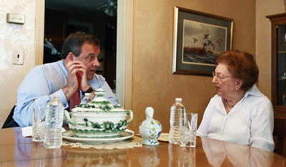In this activity, the roles are switched and AAWID is invited to ask the educator all the questions he has about the PC services. If necessary, the AAWID could use the table from the previous activity and start discussing with his educator each statement listed there. The educator should remind AAWID that there are no wrong or right questions or statements, and they just reflect together on the things AAWID considers important to them in the scope of palliative care.

Just ask! ☺