**Unit 14: Choosing end life care and palliative care**

Exercise 1: What are end-life and palliative care?

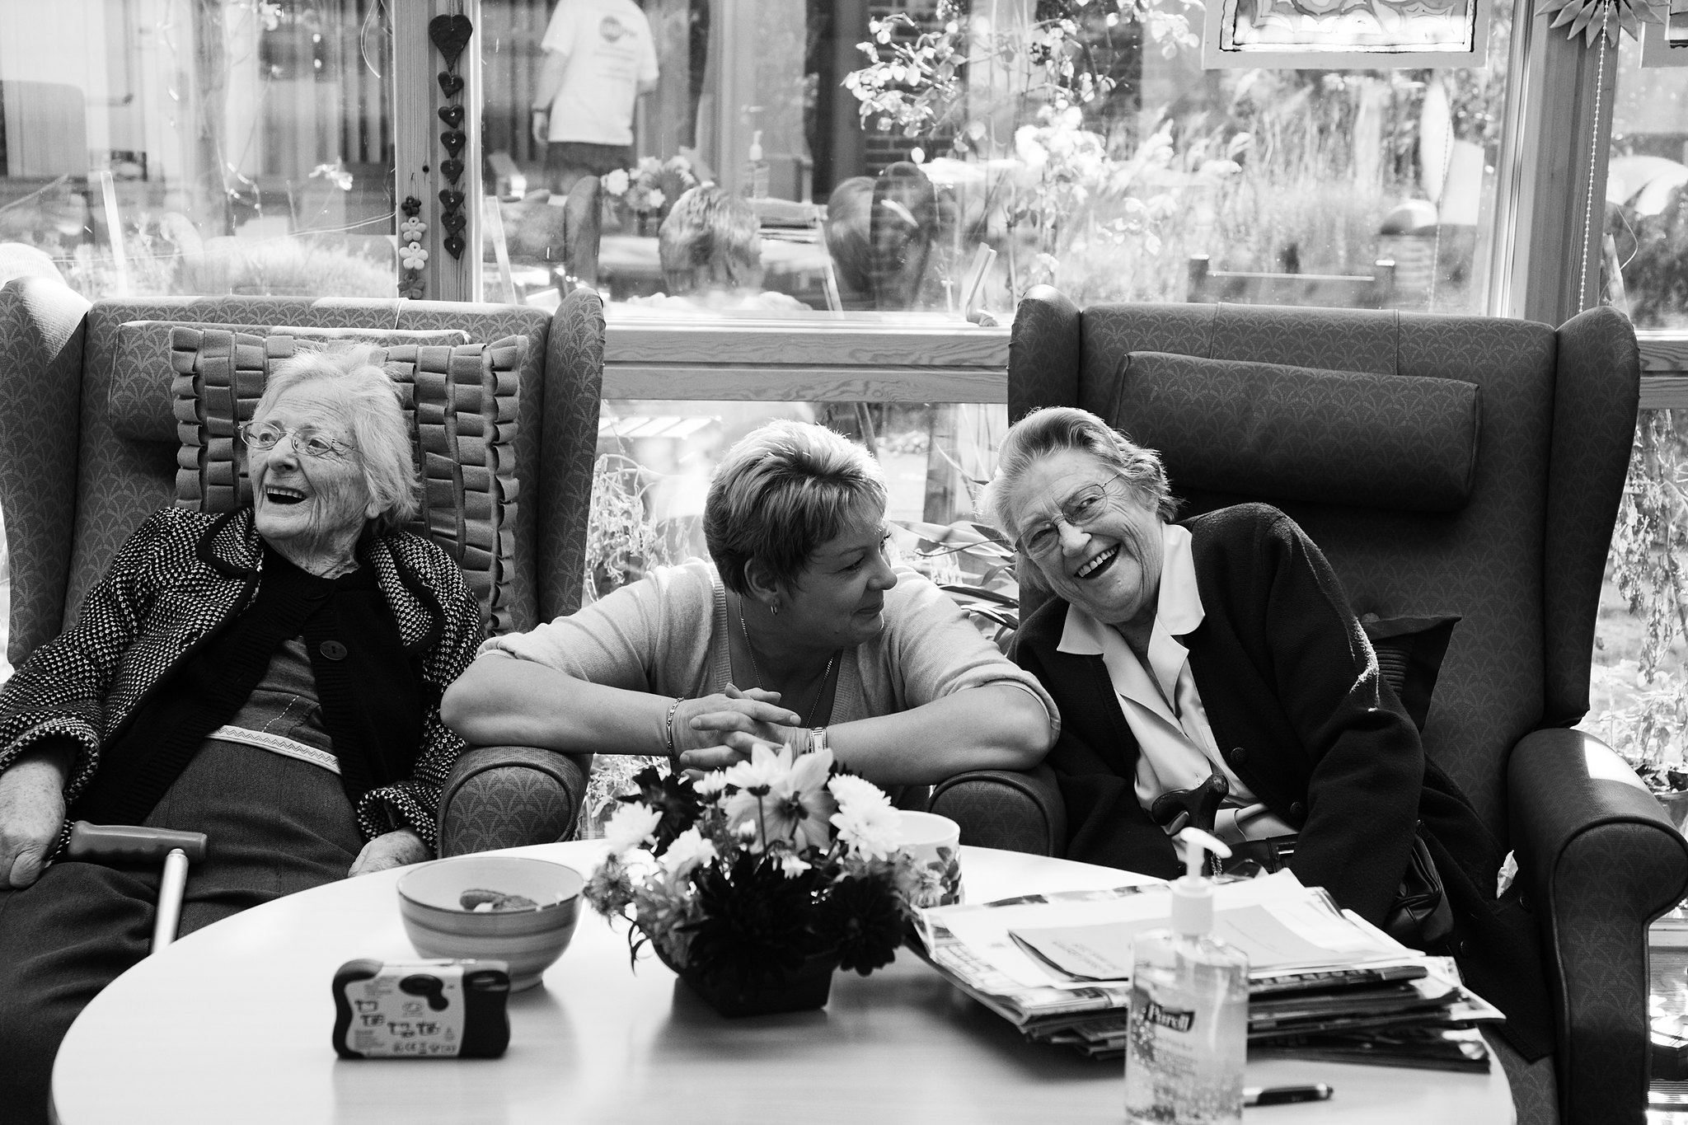

Palliative care is holistic, multidimensional, and interdisciplinary care for patients with advanced and proceeding diseases, who need relief for their suffering and a peaceful environment where they can feel at ease and supported by dedicated and qualified staff. Palliative care is an approach aiming at improving the quality of life for people with serious illnesses facing problems connected with life-threatening diseases, through prevention of suffering, personalized evaluation, pain treatment, and other somatic, psychosocial, and spiritual matters.

## *C:\Users\Admin\Desktop\5807712035_43ba5acc32_c.jpg*Activity 1: Get to know more about palliative care

*Chris is a 78 years old man who has been living independently in his home. Recently he has been diagnosed with Pancreatic Cancer and the prognosis is that his health condition and overall state will deteriorate over time. Chris has already passed a couple of courses of chemotherapy and radiation therapy, which stabilised him for a while. Despite that he is facing many difficulties – he cannot move independently anymore, i.e. go shoppingmoving freely around the house, etc.As the tumour grows slowly Chris is confronted with severe back pain, dizziness, weakness. He must take various medications and follow a special diet. In addition, Chris has to visit various medical doctors to optimize his treatment. As the time passes Chris’s needs increase constantly – he asked his personal caregiver Isabel what are the options for him. She explained to Chris that he can make use of end-life and palliative care services which will help him to receive adequate support and treatment for his body and mind. Isabel also explained that there are 2 main types of provision of palliative care (PC) – home-based and palliative care in the so-called hospices. In the next days, Chris and Isabel have watched different movies and read publications explaining what the PC stands for and what are the benefits for the patients. In the last few weeks, Chris feels intense pain which doesn’t allow him to do the usual daily activities independently. Therefore, after discussions with Isabel and consultations with other professionals who support Chris in the last years, he decided to go to a hospice in the outskirt of the same city where he lives. There Chris is surrounded by different specialists who help him to feel more comfortable.*

Isabel

Chris

*Thanks to the special treatment plan he feels pain relief and psychological support. Even supported by physiotherapists Chris does light exercises as part of his rehabilitation program.The hospice has a beautiful flower garden and Chris enjoys going there. Once per week he meets his friends from the community club in a special guest hall, meant for meetings between patients and their friends from the outside. In this way Chris spends his days peacefully, surrounded by different specialists who take good care of him.*

**INSTRUCTIONS**:

**1**. The educator should first invite AAWID to recall a story of his friend or acquaintance who has used palliative care services - what was the case, how he was supported, what were the benefits for him? If AAWID finds difficulties in remembering such a story, the educator may suggest to him the story placed in the Activity section.

The educator could help AAWID to understand the essence of the story by asking him directing questions:

- What requires Chris to use end-life and palliative care services?

- What type of services Chris receives in the hospice he choose?

- Why Isabel is helping Chris in making such an important decision?

**2.** The final part of the Activity is in the format of a quiz, as AAWID should answer three questions with three possible answers each and thus to demonstrate his knowledge and understanding regarding palliative and end-life care.

***Now it is time for reflections. Ask the following questions:***

1. When we should think about using end-life and palliative care services? 2. Where the palliative care is provided?

|  |  |  |
| --- | --- | --- |
|  | A | Only in homes for elderly. |
|  | B | In hospices or the home of the patient. |
|  | C | Only in the big hospitals. |

|  |  |  |
| --- | --- | --- |
|  | A | When we are confronted with life-threatening disease and the prognosis is misfortune and as a result feel intensive pain and suffering. |
|  | B | When we become older and need someone to help us to follow doctor`s prescriptions. |
|  | C | When we are no longer able to work, do shopping, cleaning, prepare food, etc. |

3. What we cannot expect from palliative care services?

|  |
| --- |
|  |

|  |  |  |
| --- | --- | --- |
| 9024010453_65e546be46_w | A | Pain relief and rehabilitation. |
| hospice-1821429_640 | B | Ensuring comfort and suitable medical care. |
| 3582924338_d2c26c839f_n | C | Paying utility bills. |