Unit 13: Choosing appropriate life goals and choosing activities important to me
Exercise 3: The plan is ready!

The story of Maria – final part
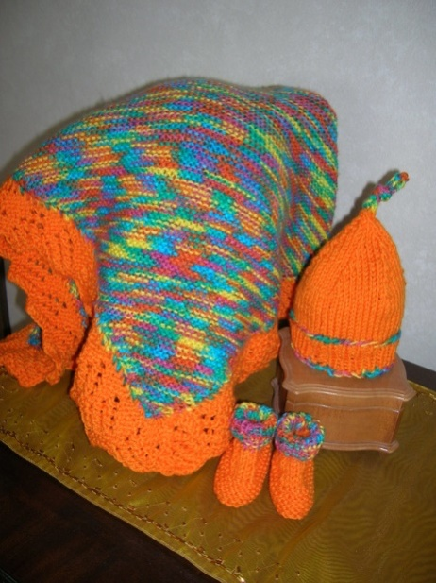
It had been a month since Maria had started knitting. She and Anna went out for their traditional weekly walk and coffee. Maria was completely ready with her plan on how to turn her favorite activity into her new life goal. She told Anna that she had met great people on the course - some of them very young and very enthusiastic, others - people of her age, looking for a new hobby. One of the young girls in the course told her about a very interesting initiative related to providing knittings to homeless people. Various NGOs, networked, recruit volunteers to knit clothes, blankets, scarves, hats, sweaters, etc. for the homeless people in Europe.
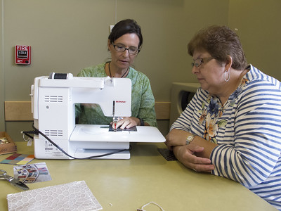
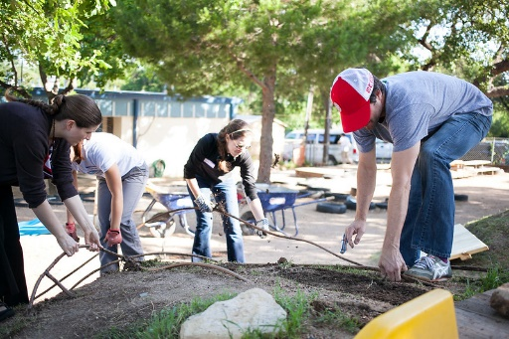
These organizations provide the volunteers with all the necessary knitting materials free of charge, and the volunteers are expected to make the knittings and leave a kind message to the person to whom they will be given.
Sofia
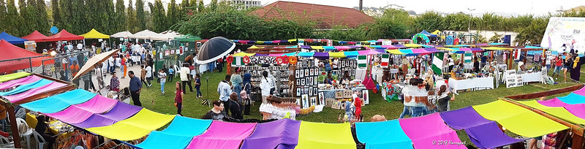
One of the older women, Sofia, however, told her that she was a volunteer for an organization that organizes charity bazaars with knitted toys to help children with disabilities, orphans, and children from very poor families.
For the last one month, Maria has been able to study the two local organizations that administrate these initiatives in her region. Then she calculated how much time a day can spend on knitting and what she could produce in a week. According to her calculations, if she spends an average of 5 hours per day, she can take part in both initiatives. Maria has contacted the two organizations and made an appointment. She had meetings with the managers of both organizations in one week. During these meetings, she fulfilled her volunteer’s applications and become their member. So far she had produced one knitted dinosaur, three hats, and three knitted scarves, and was really proud of herself. At the end of the following month, her first knittings were going to reach their new owners.

Activity1: Maria’s goal setting worksheet
This activity requires the AAWID to accomplish a goal worksheet instead of the main character. This task will provide the educator with a detailed overview of the understanding and knowledge of AAWID regarding the life goal setting up and achieving process. It is important for all unclear parts of the process to be discussed and explained once again in detail by the educator.
Maria’s new life goal is ……………………………………………………………………………………………........................................................................................................................................
Her steps to reach the goal are:
1.
2.
3.
4.
5.
6.
7.
The things that helped her to reach her goal are:
…………………………………………………………………………………………………………………………………………………………………………………………………………………………………………………………………………………………………………………………………………………………………………………………………………………………………………
How would you know if Maria has achieved her goal:
…………………………………………………………………………………………………………………………………………………………………………………………………………………………………………………………………………………………………………………………………………………………………………………………………………………………………………

Some of the exercises suggested here have been inspired by materials, published onto https://positivepsychology.com

