Unit 13: Choosing appropriate life goals and choosing activities important to me
Exercise 1: What does life goal mean?

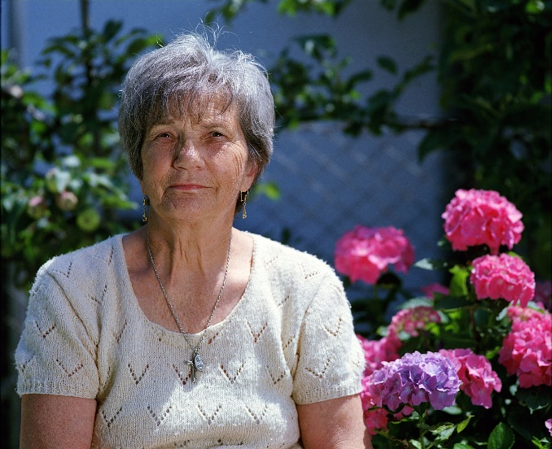
The story of Maria
Anna
Maria is а 67 years old woman. She has just retired after 40 years of her career as a medical orderly. Maria is a very active and sociable person. She is used to meeting new people every day at work, and has a great relationship with her colleagues from the hospital – some of her colleagues even became really good friends of her. So now she is a bit afraid of the retirement period. She thinks that her life would not be so active anymore and that she will become someway isolated from the surrounded world. Besides, she was thinking that her daily life will be boring and purposeless if she is not working.
Maria

Her neighbor and good friend Anna noticed that Maria’s attitude has changed during the first two weeks after retirement. She was sad, more reticent, and started to decline their usual meetings for coffee and walking.
Anna decided to find out what is happening with her friend and to find a way to help her. One day she visited Maria in her apartment and they had a very long conversation. Maria shared with Anna that she feels lonely andsuperfluous andthat she cannot find how to overcome these feelings by herself. This revelation reminded Anna how she was feeling during her post-retirement period, as she is a bit older than Maria (73 years old). Just like Maria she lives alone and has no husband or children, so that periodalso was a very hard time for her. Anna told Maria that she also felt loneliness andboredom at that time, and what helped her then was the floriculture.

Anna has always been so passionate about floriculture but this was the first time when she could devote herself entirely to it. Since then she has this lovely “garden” in her apartment. Now, Anna spends more than 4 hours every day taking care of her flowers and this not only keeps her busy enough but gives her real pleasure.

They both agreed that after retirement Maria also needs to find a new goal that would give meaning to hereveryday life. The first step to set her new goal was to find out what activity would make Maria happy, and the second one – how she could fully devote herself to it. Maria said that she really enjoys knitting but she had very little time for this while she was working. So they start thinking about how to make knitting a new life goal for Maria. First, Anna asked her a few questions:
1. What does she loveto knit (gloves, hats, blankets,sweaters, etc.)?
2. What she may do with the knittings?
3. Would she do it for pleasure or business?
Maria answered that she really loves to make colourful and cosy winter accessories and sweaters andthat in the past she loved to give them to her friends and relatives as gifts, so she prefers to keep things like that and not to sell them. Unfortunately, she hasn’t been knitting for a while and cannot remember very well the proper knitting techniques. Anna reassured her that this is no longer a problem as there are so much information and videos on the internet, so Maria will be able to catch up with knitting. During this first conversation, Anna and Maria accomplished two very important steps of the process of setting up a new life goal for Maria– the first was to find out what is the thing that would make her happy and the second – to find out how this couldbe used to satisfy her needs. Anna said that they still need to think about the prices and the amount of money needed for the supply of yarn, how the products to be distributed for free, etc., i.e. what is the pathway to this goal achievement. So they agreed to keep thinking during the next days on how Maria may achieve her new goal and to meet next week to exchange ideas.

Activity 1: What is the answer?
This activity contains a story of an aging woman with ID who has just retired and feels like she needs to set up her new “life goal” which to give meaning to her daily life from now on.

Steps:

1. AAWID and the educator should read the story very carefully. If needed, the educator could use various techniques to support the AAWID in understanding the essence of the story.
2. Then the AAWID is invited to answer four open questions regarding the decisions of the main character and her personal features, as the educator should encourage the aging person to explain in more detail each of his answers.
The idea of this activity is to allow the educator to observe what is the AAWID level of understanding regarding the life goal’s concept.

Why does Maria need to choose her new life goal?

………………………………………………………………………………………………………………………………..........................................................................................

What is Maria’s new life goal?

………………………………………………………………………………………………………………………………..........................................................................................

Why is this goal important to Maria?

………………………………………………………………………………………………………………………………..........................................................................................

What were the two steps accomplished by Maria and Anna in the process of setting up Maria’s new life goal?

………………………………………………………………………………………………………………………………..........................................................................................
Note: The educator must keep in mind that for some people with intellectual disabilities, the concept of "life goal" may be too abstract and they may have great difficulty with this exercise. In such cases, the educator should devote additional time and attention to thoroughly discuss the notion and the concept behind it.

Some of the exercises suggested here have been inspired by materials, published onto https://positivepsychology.com

