Unit 12: Who are the persons important to me?
Exercise 3: My colleagues

George’s story - part 3

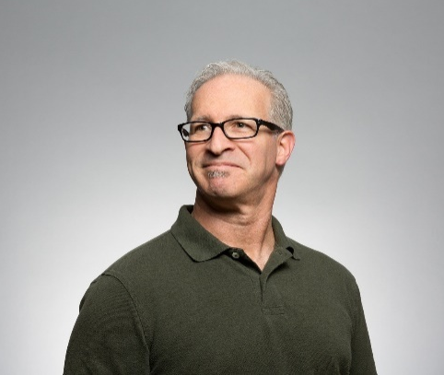  George | 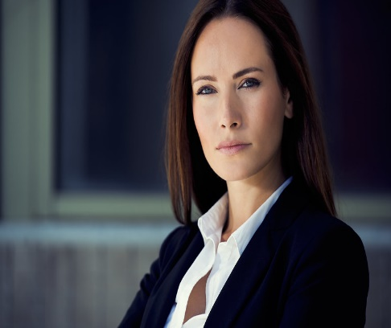  Maya
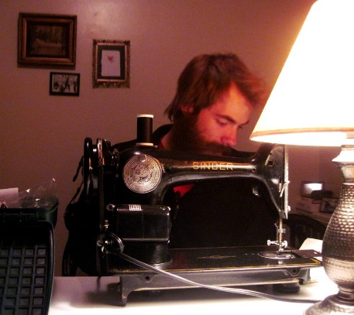David | 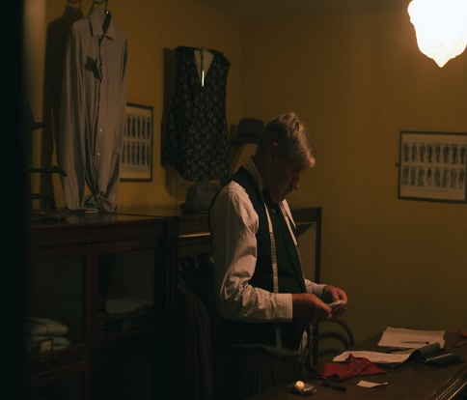Mario
Recently George started to work in a new tailor workshop in his hometown. Here the working team is smaller than the one in the big workshop, however, George got in touch with really nice colleagues. For instance, last Tuesday he was introduced to Maya who is the senior assistant of the famous tailor who runs the workshop. She warmly welcomed George and has shown to him the whole workshop – all facilities, the equipment and materials used in the sewing process. David is another colleague of George with whom they work together every day. Davis is also one of the assistants in the tailor workshop, as he has been working there for more than three years. David had the task to introduce George to the working process and to support him with the daily tasks during his first months in the company. David and George’s work is being supervised by Mario who is the most experienced and long-term employee in the workshop. Mario always gives George useful guidelines about how to improve his performance at work. Last Friday, for example, George had difficulties to finish one of the orders – one elegant black blazer, meant for the Deputy Mayor of the town. While George was working on thelapel of the blazer he made a mistake and it seemed that he cannot meet the deadline of the order. In this challenging moment, Mario noticed the mistake and quickly found a solution – he worked together with George one hour extra, so they managed to finish the blazer on time.

Activity 2: George as part of a working team

AAWID should write down the senior colleagues of the main character in the story and explain how they support him in his work.

Who are the senior colleagues of George and how they support him in his work?

