Unit 11: Learning about your rights

Exercise 3: Actions for my rights’ protection

The story of Philip – part II
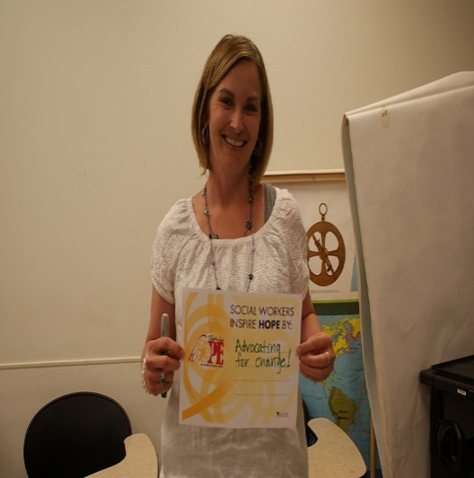
Philip decides to share what is happening in his family with his neighbour Anna, with whom he is very close. Since Anna lives alone, she often asks Philip to help her with various housekeeping and yard maintenance activities, which has brought them closer together over time. Anna is aware that Philip’s brother is doing unfairly and decides to help Philip find a way out of the situation and keep his home. She suggests him they together to visit the social services in their city and see what could be done. There they meet Maria, a long- term social worker. What Maria explains to them first is that despite Philip’s brother’s arguments, he cannot sell their home without Philip’s explicit consent, stated in person in front of a notary. So Philip has nothing to worry about in this regard, but it’s good, she tells him, to discuss his brother’s other arguments about caring for the home and their sick mother. She confirmed to Philip that caring for a vulnerable adult person with medical complications and meanwhile maintaining a whole household and the building would be a daunting task for everyone. However, Philip could count on outside help for this. Maria lists various social services that Philip and his mother can apply for and ask him to visit them at their home in two days, so the three of them to discuss this.
Anna

Philip
Maria

Activity 1: What are the initial steps, taken by Philip to protect his own and his mother’s rights?
This exercise contains a continuation of the story from the previous exercise and one Activity 1 entitled “What are the initial steps, taken by Philip to protect his own and his mother’s rights”. The exercise is dedicated to the protection of rights. This part of the story represents how a person with special needs, whose rights are about to be violated, seeks, and finds help and support to counter.
Steps:

1. The educator and AAWID read the story carefully and have a brief discussion on it, as it is expected AAWID to recognize and remember the separate steps and actions taken by the main character.

2. Then AAWID is invited by the educator to repeat (orally or on a list of a paper) and to explain each of them from his point of view.

3. The educator could support AAWID by asking him directing questions like:
- Why Philip decided to share his problems with Ana?
- How Ana supported Philip?
- What was the first action they both decide to take?

1

2

3

