Unit 11: Learning about your rights

Exercise 2: My rights are about to be violated – what to do?

The story of Philip – part I
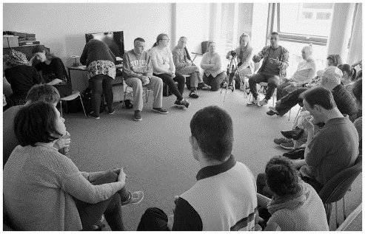
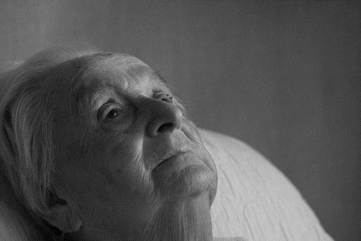
Philip is a 57-year-old man who lives in a small town with his 78 -year-old mother. Philip cannot take care of himself and relies on the help of his mother and brother, who live in a nearby bigger city. Philip’s mother takes care of the household, with Philip helping her with the various activities, incl. washing clothes, cooking and cleaning the home, and the technical maintenance of the building and the yard. Philip’s brother visits them every weekend when bringing them food and other provisions that Philip and his mother said they need, and helping them with home maintenance.
Philip
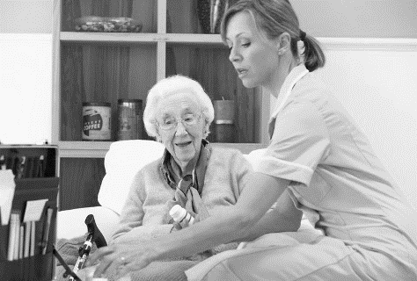
Unfortunately, Philip’s mother’s health deteriorates sharply and she is not longer able to take care of their household. His brother decides that Philip will not be able to take care of them both at home and decides to sell their house and accommodate them both in social institutions - his mother in a home for the elderly and Philip in a home for the elderly with disabilities. However, Philip does not agree with this decision and insists that they stay in their home, but his brother says that unfortunately he cannot find another solution for three of them, so he is adamant that they should be accommodated in specialized institutions.

Activity 1: Violated rights
This exercise aims to show the AAWID that although we all are granted specific rights sometimes they could be violated, and in many cases from people who are very close to us. The exercise contains a story and one Activity 1 entitled “Violated rights”. The story explains a similar situation where an ageing man with ID is forced by his brother to leave his home and move to a social institution for elderly people with ID.

Steps:

1.The educator and AAWID read the story carefully and have a short discussion on it;

2. Then he provides to the AAWID a list and a pen and challenges him to answer the question of which of the main character’s rights are about to be violated by his brother and in what way. Depending on the level of understanding of AAWID the educator can use the cards with the rights/wishes from the previous exercises and can ask the AAWID to list them orally instead of writing them on a piece of paper.

3.The educator could assist AAWID by asking him supporting questions like:

•Is it a wish that Philip wants to keep on living in his house? Why do you think so?
•Has he the right to decide where to live? Why do you think so?
•Has Philip’s brother the right to decide on the name of Philip and their mother? Why do you think so?

Note: It is important, regardless of the answer given by the AAWID, both the educator and the AAWID to discuss well the rights indicated by AAWID and to discuss together and in more detail the correct answers.

