Exercise 10.2. Search for information on the Internet

****

The objective of this exercise is for AAWID to learn how they can find useful information on the Internet and how they should use social media.

Activity 1. Exercises on the Internet

This activity is for participants who are able to use the Internet (with or without the trainer support).

Go to the Internet - Google

1. Search for the website of the local service cent



* 1. What are the opening hours of the service center?



* 1. Are there specific services or activities for elderly people (seniors)? Please, select two activities that you would like to know more about.



* 1. Do they have specific services for people with disabilities? Please, select one service you would like to know more about.



1. Search for the website of the local transport (bus/metro/tram)

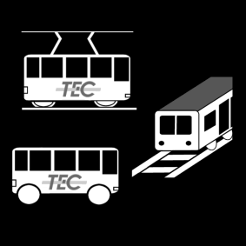

* 1. Look for a bus number of a bus that stops close to your house.



* 1. At what time in the morning comes the first bus?

  

* 1. At what time in the evening leaves the latest bus?

  

1. Search for the local weather
   1. What is the weather like today?

 

1. Search for information about healthy food.



1. Search for the recipe to make a chocolate cake

 

Activity 2. Should I take an Internet course?

In this activity, support the participant to reflect upon the following questions:

* Did you find this exercise difficult or easy to do? Please, explain your answer.
* Would you like to do a training course about how the use the Internet?
* Who else might help you to learn how to use the internet?