Exercise 10.1. Using internet and social media

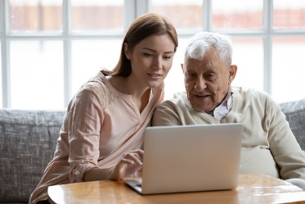

The aim of this exercise is for AAWID to learn about the benefits of the internet and social media.

Activity 1. Do you use internet and/or social media?

Before you begin with this exercise, ask the person/the group if they are able to use a computer. Do they already have basic digital skills, know how to use a browser, know how to navigate by ‘Google’…?



Ask the person/the group if they have access to a computer or a tablet, Who has his/her own computer/tablet?, Who has internet access?

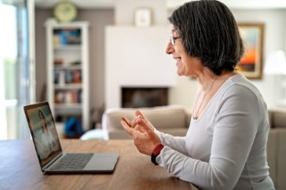

Ask the participants if they know if they are connected to the internet or not. Show the picture below, or ask them to show you on a computer or/and a smart-phone.



Ask the participants what would happen if they are not connected to the internet. Then ask them if they know how to solve the problem on the computer or smart-phone. Let them to show you.

Where should they go when they don’t have access to internet at home? A Local library?

Activity 2. Why do people use the internet?

The objective of this activity is to start a conversation with the participants about why people use the internet. To use social media, you also need to have an internet connection.

To learn more about the use of digital devices and social media, take a look at the exercises of unit 7 (exercise 2.3 and 3).

|  |  |  |
| --- | --- | --- |
| **Surf the Internet** | Yes | No |
| Search for information.  https://www.sclera.be/resources/pictos/computer%20surfen%20explorer%20t.png |  |  |
| To communicate with family and friends.  Ex. via email, Messenger, WhatsApp, Skype, Facetime, Facebook...  https://www.sclera.be/resources/pictos/computer%20chatten%20t.png |  |  |
| To share photos with family and friends.  https://www.sclera.be/resources/pictos/computer%20foto%20kijken%20t.png |  |  |
| To search for ‘old’ friends or ‘old’ colleagues via Facebook. |  |  |
| Others |  |  |

All pictures used in this document are downloaded from pixabay.com/nl.