Exercise 9.3. ‘Social roles that are important to me’

The aim of this exercise is to support participants in defining new social roles they would like to take on when they become older. In contrast to previous exercise where the focus was on helping people they know, like acquaintances or neighbours, the purpose is now to support AAWID in contributing to society by doing voluntary work or community work.

Activity 1: Make your own poster

This first activity is only for participants that didn’t do exercise 9.2.

To know what social role you would like to fulfil, let’s have a look at the activities you really like doing or were you are good at.

As an example, please look at the poster of Paul

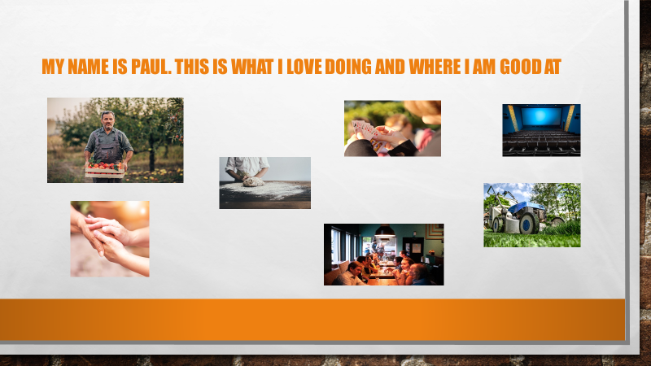

Now make your own poster.

When you finished making the poster, tell the other participants in the group what is on your poster.

Note:
If the exercise is done individually, the participant can be asked to tell what is on the poster to the trainer or to a friend or family member.
Activity 2: My social roles poster

The aim of this activity is to aid participants to think about activities through which they can contribute to society. Let the person/the group think about activities that match with their talent(s) and let them think about how they can do this activities (for example: by doing voluntary work, by being involved in a local community group).

Note:
Most participants will need support finding out if there is voluntary work or if there are local community groups they could join.

Now that you know your favourite activities or things you are good at, the idea is to find out how you can use them and in the same time play a social role. Look for social roles poster of Paul:

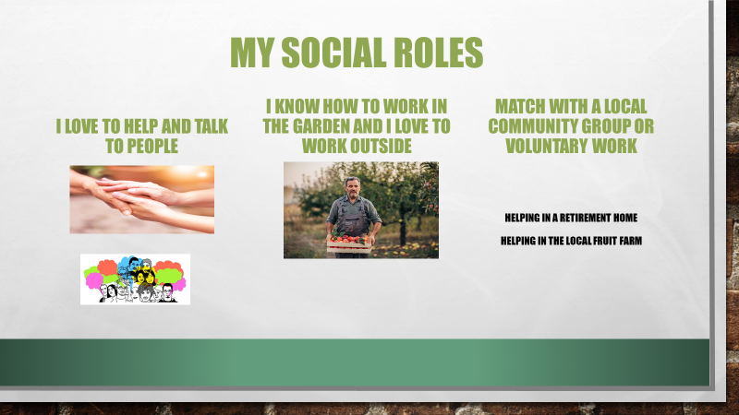
Support the participant in making his/her own social roles poster. If the participant understands, you may also ask him/her the following questions:

- Do you know some organizations/associations in your neighbourhood (e.g.: tennis club, cycling club, knitting club…)?

- Are you a member of an association? Is it important for you to be a member of an association?

- Are you currently doing volunteer work?

Who can help you to make a choice about what you want to do?

Now make your own social roles poster.

