Exercise 9.1. The notion of ‘having a social role to play’

The goal of this first exercise is to find out to what extent participants understand the notion of ‘having a social role’. We start this exercise with a short story. Ask the participants to carefully listen to the story because they will be asked to do a small quiz.

**Note:**

You may add other materials/films that explore a situation of people having a social role. It is always most useful to show films of local people if possible.

The story of Paul

Paul is a man of 67 years old who has a lot of energy and who is physically still very well. He is also a very social person, he loves talking to other people.

Paul has worked his whole life in a sheltered workplace. At the end of his carrier he was responsible for all new employees, showing them around and helping them get acquainted with the other employees who worked there. He was important to the company.

At the age of 65, Paul had to retire. Paul wanted to stay active and help other people, just as he always did at the sheltered workplace. Together with his support worker named ‘Steffi’, he started the search for new things to do during the day. Paul really wanted to work rather than spending his time at home.

Steffi found two places in the neighbourhood where Paul could work as a volunteer and help out. For two half days, he now works as helper in the kitchen of a retirement home. He is the help of the cook.

The other days of the week, he sometimes helps out at the local fruit farm. Paul loves working there. He knows the boss of the fruit farm since he was a small child. They get along great. Paul is happy because he can finally work outside, something he always liked to do.

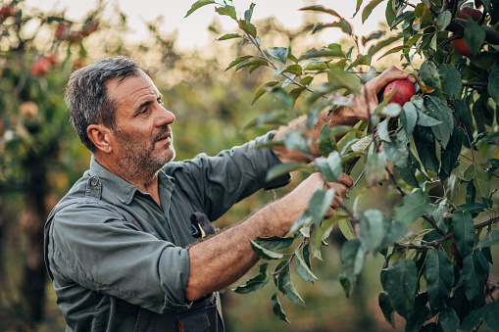

During his free time, on Monday afternoon, Paul is a member of the Okra. The Okra is an association for elderly people. They do all kinds of fun things in the Okra like playing cards or singing songs, riding a bike or going to the movies together.

Afbeelding met persoon

Beschrijving is gegenereerd met zeer hoge betrouwbaarheid

Activity 1: Quiz

Ask the participants if they agree with the following statements.

|  |  |  |
| --- | --- | --- |
| 1.Paul likes to help other people  https://www.sclera.be/resources/pictos/gebaar%20helpen%20t.png | Agree | Disagree |
| 2. Paul doesn’t like to do a lot of activities. He wants to be at ease.  https://www.sclera.be/resources/pictos/zitten%20zetel%20t.png | Agree | Disagree |
| 3. It’s important for Paul that he can keep on working.  https://www.sclera.be/resources/pictos/werken%20t.png https://www.sclera.be/resources/pictos/tuin%20t.png | Agree | Disagree |
| 4. Paul does voluntary work in his neighbourhood.  https://www.sclera.be/resources/pictos/werken%20t.png https://www.sclera.be/resources/pictos/geld%20t.png | Agree | Disagree |
| 5. Paul is not a member of an association for the elderly in his neighbourhood.  https://www.sclera.be/resources/pictos/kring%20t.png | Agree | Disagree |

Activity 2: What are the social roles of Paul?

In this exercise you start by asking the participants if they know the concept of having a social role. Use the story of Paul to explain how he changed this social role when he retired. First he was working within a sheltered workplace where he had the responsibility to support new employees. Did he get new social roles when he retired?

*Having a social role means:*

1. helping others

2. taking responsibility (small or large, durable or temporary)

3. having an active position and participating in the context you live in.

Activity 3: Find the social roles in the story of Annie, George and Liesbeth?

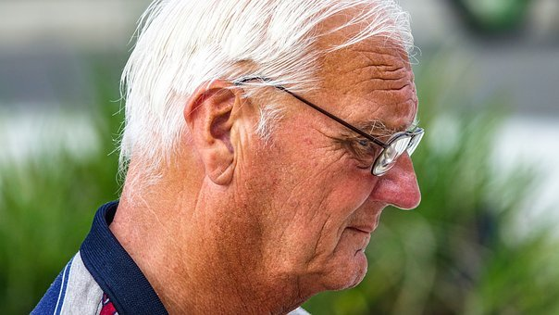

Here are some more stories to help participants figure out the meaning of having social roles. Tell the stories of Annie, George and Liesbeth. What social role do they have?

Annie

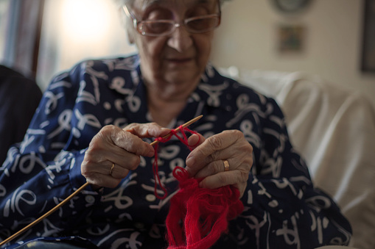

Hi, I'm Annie. I'm 60 years old. I retired and stopped working last year. I used to work in a candle workshop. My greatest passion is knitting. Since my retirement, twice a week I go to the community centre and participate in a knitting class. I am the assistant to the teacher. If anyone has problems with their knitting, I help out. I like helping others.

Ask the participants what used to be the social role of Annie when she was still working. Then, ask them if they feel she has a different role to play now.

George

Hi, I'm George. I'm 68 years old. Two afternoons per week, I take care of the plants of some people that live in the retirement home in my neighbourhood. Also I help the gardener with the maintenance of the garden. For example, I mow the lawn, water to the plants and flowers, cut the brunches when needed...

I like talking with the people who live at the retirement home. I can go there on foot, it is near the house where I live.

Ask the participants what they think is the social role of George and why this is a social role.

Liesbeth

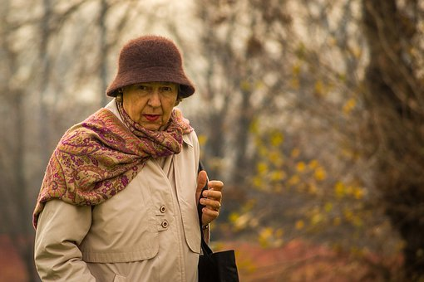

Hi, I'm Liesbeth. I am 64 years old.

I live together with nine other persons. I used to work in a day care center and mainly did the laundry and ironing of the work clothes. Now I'm not going to work anymore, but I'm still doing the laundry and ironing of my housemates every day. I enjoy being busy with that. I then put on my favorite music and get to work. My housemates admire me very much. They are very satisfied because I do their laundry. They can't take this away from me. I want to do this the rest of my life.

Ask if Liesbeth is taking on a new social role or if she still does the same thing but for different people.

Activity 4: Examples of social roles?

This exercise is about supporting AAWID to think about social roles they or other people have experienced until now.

Ask what they do to help others (neighbours/family/friends…).

Ask how they take responsibility.

Ask how they participate in society.

To carry out this activity, you might make a card game with all pictures showed in the next page. Each picture is an example of having a social role, an example of helping others, of taking responsibility, of contributing to society.

Let the participants take a card, each in turn, and let them talk about the example on the card. Do they recognize the example? Let them talk about their own experiences linked to the example on the card.

**Note:**

Adapt the examples according to the participants of the training. ‘Someone’ can be a family member, a neighbour, someone who lives nearby…

|  |  |
| --- | --- |
| https://www.sclera.be/resources/pictos/winkelen%20t.png  bring groceries for someone | https://www.sclera.be/resources/pictos/schoonmaken%20t.png  help someone with cleaning his/her house |
| https://www.sclera.be/resources/pictos/groenten%20t.png  help in the vegetable garden of the local community | https://www.sclera.be/resources/pictos/natuurles%20t.png  be a member of an association that is commited to the preservation of nature |
| https://www.sclera.be/resources/pictos/wandelen%20groep%20t.png  go for walks with people who want company | https://www.sclera.be/resources/pictos/geld%20briefjes%20t.png  do charity/raising money for a good cause |
| https://www.sclera.be/resources/pictos/hond%20wandelen%203%20t.png  take care of someone’s dog | https://www.sclera.be/resources/pictos/ganzenbord%20t.png  play board games with others |
| https://www.sclera.be/resources/pictos/zwemmen%20t.png  go swimming with someone who can’t go swimming alone | https://www.sclera.be/resources/pictos/tuin%20t.png  work in someone’s garden |
| https://www.sclera.be/resources/pictos/cafetaria%20t.png  help in the bar of a residential home for the elderly | https://www.sclera.be/resources/pictos/breien%20t.png  knit scarves/blankets for children staying in a hospital |
| https://www.sclera.be/resources/pictos/kinderdagverblijf%203%20t.png  help in the local daycare (helping with the meal, playing with the children) | https://www.sclera.be/resources/pictos/koken%203%20t.png  prepare a meal with someone who can’t cook |
| https://www.sclera.be/resources/pictos/werken%20t.png | help in the local service centre |

All pictures used in this document are downloaded from pixabay.com/nl.