Exercise 8.3: My dream retirement plan

Afbeelding met tekst, kantoorartikelen, envelop, document

Beschrijving is gegenereerd met zeer hoge betrouwbaarheid

Pictures used in this manual (and annex’s) have been downloaded from pixabay.com and sclera.be

CONTENT

Exercise 3: My dream retirement plan 2

**My retirement plan**……………..……………………………………..……..2

Activity 1: What about when I retire?….…..….…………….……..……...2

Activity 2: Do I stop, reduce or keep working?................................3

Activity 3: What type of voluntary work would I like to try-out ?...3

Activity 4: What type of voluntary work would I like to try-out ?..4

Annexes............................................................................................5

My dream retirement plan

This Exercise captures the learning acquired so far in this unit. The following activities focus on reflection and actions to start thinking about a possible retirement plan for themselves. Some participants will require additional time and support as most Activities are more individually.

**Note:** If the participant doesn’t want to join in these activity, that’s okay. But don’t give up, this person may want to engage in this topic in the future. You might involve him/her in other activities. For example by creating a situation so he/she can listen in. You may involve other friends or housemates of the participant. Or else you could also ask the participant as a co-tutor during a conversation about related topics.

Activity 1: What about when I retire?

Please start this activity with a recap of Exercise 8.1. You can refer to the story of Isabel or the activities of Exercise 8.1.

Afterwards, ask the participants to imagine…  their own retirement.

Give them 5 minutes to answer the following two questions separately. If the activity is too difficult, give an example or let them do the activity in pairs.

1. If you were to retire, what are the two worst things that could happen to you? What are you afraid of?



Worst things that could happen.

1.

2.

2. If you were to retire, what are the two best things that could happen to you? What do you dream of?



Best things that could happen.

1.

2.

After completion of the activity sheet, ask them to feed back their responses and capture what they say on a whiteboard or flipchart.

Clearly there are no right or wrong answers. Generate a discussion about their fears.

Activity 2: Do I stop, reduce or keep working?

Print out Activity 2 (Annex 1, page 5) for all participants.

Print out and laminate the following three cards. Make them bigger if needed.

|  |  |  |
| --- | --- | --- |
| **Afbeelding met teken, straat, verkeer  Beschrijving is gegenereerd met zeer hoge betrouwbaarheid**  **Keep working** | **Afbeelding met teken, straat, verkeer  Beschrijving is gegenereerd met zeer hoge betrouwbaarheid**  **Reduce working hours** | **Afbeelding met teken, straat, verkeer  Beschrijving is gegenereerd met zeer hoge betrouwbaarheid**  **Stop working** |

Ask the participant “Which card matches best with your current retirement dream plan?”

Give each participant the corresponding worksheet (annex 1) and ask them to work by themselves. Give them 20 minutes or more if needed. Take a break if needed. If the Activity is too difficult, go through the questions together. Help them select those questions that they need to answer.

Activity 3: which leisure activities would I prefer doing?

The aim of this Activity is to help participants think about activities they dream of doing when retiring. (annex 2, page 11)

****

Four strategies that may support AAWID in creating their collage.

1. Show them the collage of Marie’s dream activities. (annex 2)
2. Give them the list of leisure/recreational/hobbies.
3. Invite the network (family, friends, confidants, …) to help with building the collage.
4. Talk about things of the past, of when they were younger, still kids, what they did but also what they wished to have learned.

Give the participants the opportunity to make their own personal collage. E.g. if the person likes to look online for pictures, use a notebook or other electronic devices. Or do it the more traditional way, and let them just cut out pictures from magazines or ask them to take pictures with their smartphone.

Another possibility is to give homework. Ask participants to talk about their dream activities with their family, friends, co-residence or support workers.

Activity 4: What type of voluntary work would I like to try-out ? (Annex 3)

Start with a short recap of activity 6 (unit 8 - exercise 2). As in activity 6, use pictures or descriptions of local community voluntary work if necessary.

The aim of this activity is to support AAWID to identify their preferences in voluntary work. Print out annex 3, page 13 .

First ask the participants to:

* Look at the pictures of different things to do in voluntary work.
* Think about what they like and listen to the choices.
* Select those that are best for you.

Example:

|  |  |  |
| --- | --- | --- |
| **C:\Users\igoe177\OneDrive - Hogeschool Gent\TRIADE 2.0\IT platform\oefeningen\Nieuwe map\english\outside_2.pngoutside** | **C:\Users\igoe177\OneDrive - Hogeschool Gent\TRIADE 2.0\IT platform\oefeningen\Nieuwe map\english\inside_2.pnginside** | **no preference** |

Secondly, ask them to select the type of voluntary work they would perhaps like to try out. They will be asked to select the sector.

|  |  |  |
| --- | --- | --- |
| C:\Users\igoe177\OneDrive - Hogeschool Gent\TRIADE 2.0\IT platform\oefeningen\Nieuwe map\english\seniors care.png Eldery care | Duim omhoog | Duim omhoog |

Help AAWID in making it more concrete, based on the local voluntary job availabilities. For example, if the choice is to do something within the elderly care, you could give examples such as: taking walks with an elderly person who is lonely. Helping in the cafeteria of an elderly home. Having a coffee with an elderly person. Etc.

UNIT 8 – Exercise 3 - Activity 2 – annex 1

Activity 2: Do I stop, reduce or keep working

Which card matches best with your dream retirement plan? Select your card.

|  |  |  |
| --- | --- | --- |
| **Keep working**  **Afbeelding met teken, straat, verkeer  Beschrijving is gegenereerd met zeer hoge betrouwbaarheid** | **Afbeelding met teken, straat, verkeer  Beschrijving is gegenereerd met zeer hoge betrouwbaarheid**    **Reduce working hours** | **Afbeelding met teken, straat, verkeer  Beschrijving is gegenereerd met zeer hoge betrouwbaarheid**  **Stop working** |

Worksheet keep working

|  |
| --- |
| **Afbeelding met teken, straat, verkeer  Beschrijving is gegenereerd met zeer hoge betrouwbaarheid**  **Keep working** |

If your dream is to **keep working**, answer the following questions.

How many days, or half days, are you currently at work?

* *Colour the days (or half days) you work bleu.*

Monday Tuesday Wednesday Thursday Friday Saturday Sunday

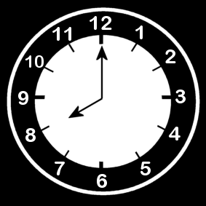

Do you know when you would be ready to reduce or stop working? Which statements fit with your idea?

* When I am old enough. When I am …..years old.
* When I am no longer up for it and feel tired all the time.
* When I start to be bored with my job.
* When some of the tasks at work become too difficult for me.
* When I am too sick to continue working.
* When I have other better things to do during the day.
* When I have the financial means to retire.
* When I am sure that I will still be able to see my friends from work.
* When I am sure that I will be able to do other things that I like doing.
* Other reason(s):………………………………………………………………………….

Worksheet: reducing working hours

|  |
| --- |
| **Afbeelding met teken, straat, verkeer  Beschrijving is gegenereerd met zeer hoge betrouwbaarheidReduce working hours** |

If your dream is **reduce working hours**, answer the following questions.

How many days, or half days, are you working now?

* *Colour the days (or half days) you work* **bleu.**

Monday Tuesday Wednesday Thursday Friday Saturday Sunday



In your dream, how many days or half days are you still working?

* Colour them **grey**

Monday Tuesday Wednesday Thursday Friday Saturday Sunday

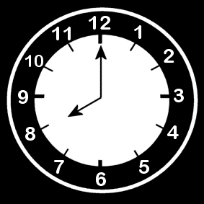

During the off work days, how active would you like to be?

* Colour the days at work **black.**
* Colour the days off work:Green = very active / Orange= active + relaxing/ Red = relaxing

Monday Tuesday Wednesday Thursday Friday Saturday Sunday



Worksheet: Stop working

|  |
| --- |
| **Afbeelding met teken, straat, verkeer  Beschrijving is gegenereerd met zeer hoge betrouwbaarheid Stop working** |

If your card is to stop working, answer the following questions.

If you choose to full-time retire from work, how active would you like to be?

* Colour the days: Green = very active/ Orange = active + relaxing/ Red = relaxing

Monday Tuesday Wednesday Thursday Friday Saturday Sunday



UNIT 8 – Exercise 3 - Activity 3 – annex 2

Afbeelding met speelgoed, pop

Beschrijving is gegenereerd met zeer hoge betrouwbaarheidwear a uniform

Activities I dream of doing when I retire

Marie’s dream activities

Afbeelding met persoon

Beschrijving is gegenereerd met zeer hoge betrouwbaarheidPlay cards withfriends

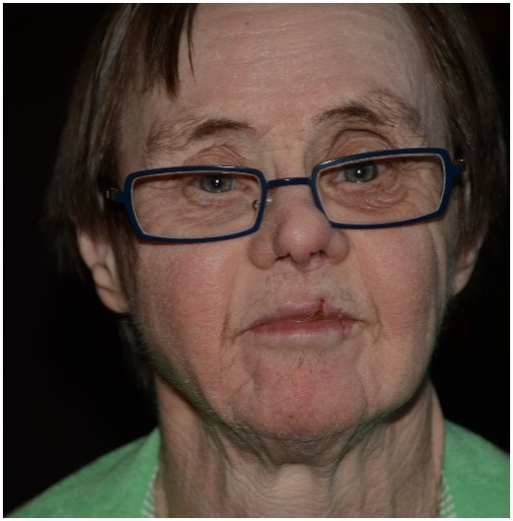

Afbeelding met tekst, binnen, persoon, elektronica

Beschrijving is gegenereerd met zeer hoge betrouwbaarheidLearntouse WhatsApp

Afbeelding met kat, zoogdier, huiskat

Beschrijving is gegenereerd met zeer hoge betrouwbaarheidTaking care of cat

**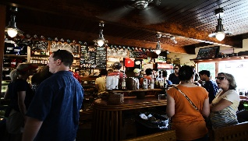**Work in a bar



Learn to take a bus to visit brother

**MY DREAM ACTIVITIES**

****

UNIT 8 – Exercise 3 - Activity 4 – Annex 3

Conditions for voluntary work

*Filip’ s conditions for voluntary work were that he could do* ***different things****, something* ***outside of the house****,* ***not sitting*** *down,* ***meet people****, use* ***his hands****, and if possible, work with* ***animals****.*

Now select what would be important conditions for you?

|  |  |  |
| --- | --- | --- |
| **C:\Users\igoe177\OneDrive - Hogeschool Gent\TRIADE 2.0\IT platform\oefeningen\Nieuwe map\english\outside_2.png outside** | **C:\Users\igoe177\OneDrive - Hogeschool Gent\TRIADE 2.0\IT platform\oefeningen\Nieuwe map\english\inside_2.png inside** | **no preference** |
| **C:\Users\igoe177\OneDrive - Hogeschool Gent\TRIADE 2.0\IT platform\oefeningen\Nieuwe map\english\standing workbench_1.png standing** | **C:\Users\igoe177\OneDrive - Hogeschool Gent\TRIADE 2.0\IT platform\oefeningen\Nieuwe map\english\sit_12.png sitting** | **no preference** |
| **C:\Users\igoe177\OneDrive - Hogeschool Gent\TRIADE 2.0\IT platform\oefeningen\Nieuwe map\english\Handyman.png using hands** | **C:\Users\igoe177\OneDrive - Hogeschool Gent\TRIADE 2.0\IT platform\oefeningen\Nieuwe map\english\work on the computer.png using mind** | **no preference** |
| **C:\Users\igoe177\OneDrive - Hogeschool Gent\TRIADE 2.0\IT platform\oefeningen\Nieuwe map\english\group work together_1.pngwith people** | **C:\Users\igoe177\OneDrive - Hogeschool Gent\TRIADE 2.0\IT platform\oefeningen\Nieuwe map\english\work independent_2.png alone** | **no preference** |
| **C:\Users\igoe177\OneDrive - Hogeschool Gent\TRIADE 2.0\IT platform\oefeningen\Nieuwe map\english\animals_3.png animals** | **C:\Users\igoe177\OneDrive - Hogeschool Gent\TRIADE 2.0\IT platform\oefeningen\Nieuwe map\english\animals_5.png no animals** | **no preference** |
| **C:\Users\igoe177\OneDrive - Hogeschool Gent\TRIADE 2.0\IT platform\oefeningen\Nieuwe map\english\work systematic_1.png routine** | **C:\Users\igoe177\OneDrive - Hogeschool Gent\TRIADE 2.0\IT platform\oefeningen\Nieuwe map\english\work take a decision.pngdo different things** | **no preference** |

Voluntary work sectors

*Filip wanted to do voluntary work in the* ***sector of sports*** *or the* ***sector of leisure*** *time.*

In which sectors would you like to do voluntary work?

|  |  |  |
| --- | --- | --- |
| Age group | * small children * adolescents * adults * eldery |  |
| C:\Users\igoe177\OneDrive - Hogeschool Gent\TRIADE 2.0\IT platform\oefeningen\Nieuwe map\english\sports.pngSports | Duim omhoog | Duim omhoog |
| C:\Users\igoe177\OneDrive - Hogeschool Gent\TRIADE 2.0\IT platform\oefeningen\Nieuwe map\english\logistical assistance care institution.png Health care | Duim omhoog | Duim omhoog |
| C:\Users\igoe177\OneDrive - Hogeschool Gent\TRIADE 2.0\IT platform\oefeningen\Nieuwe map\english\school_4.PNG School/eduction | Duim omhoog | Duim omhoog |
| C:\Users\igoe177\OneDrive - Hogeschool Gent\TRIADE 2.0\IT platform\oefeningen\Nieuwe map\english\seniors care.png Eldery care | Duim omhoog | Duim omhoog |
| C:\Users\igoe177\OneDrive - Hogeschool Gent\TRIADE 2.0\IT platform\oefeningen\Nieuwe map\english\museum_1.png Cultural sector | Duim omhoog | Duim omhoog |
| Leisure | Duim omhoog | Duim omhoog |

|  |  |  |
| --- | --- | --- |
| C:\Users\igoe177\OneDrive - Hogeschool Gent\TRIADE 2.0\IT platform\oefeningen\Nieuwe map\english\man and nature.png Nature | Duim omhoog | Duim omhoog |
| C:\Users\igoe177\OneDrive - Hogeschool Gent\TRIADE 2.0\IT platform\oefeningen\Nieuwe map\english\animals_3.png Animal | Duim omhoog | Duim omhoog |
| C:\Users\igoe177\OneDrive - Hogeschool Gent\TRIADE 2.0\IT platform\oefeningen\Nieuwe map\english\farm_5.png Agriculture | Duim omhoog | Duim omhoog |
| Other: | Duim omhoog | Duim omhoog |