ANNEX 2: Chapter 1_Cards exercise 1 & 2

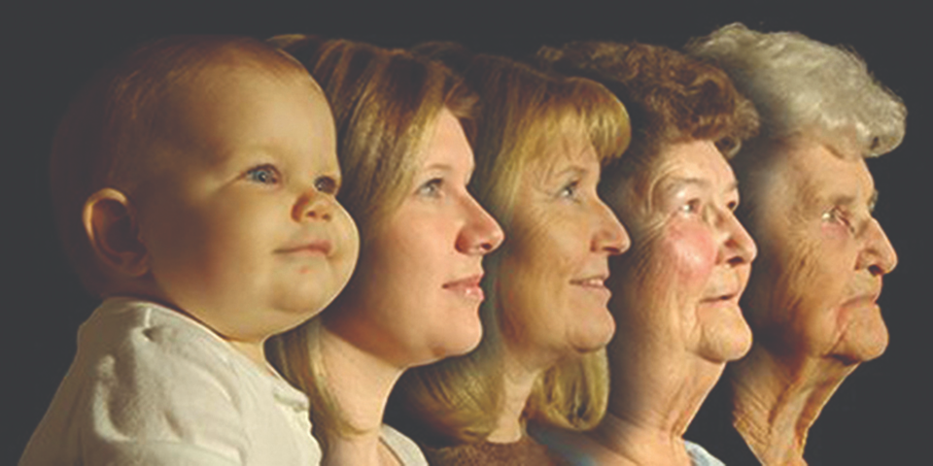  80  65  40  20 year  1 | Age  They may discuss at what age people retire. | Green zone.  Age is not always the reason for AAWID to retire. Some might be 40 while others still work at 70 years of age.
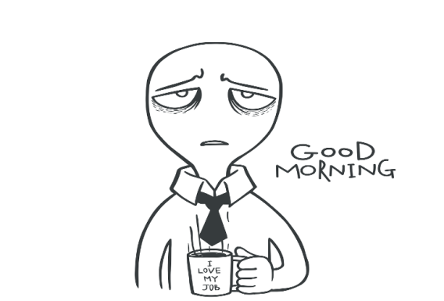 | Tiredness | Green column  2nd most common reason for AAWID
 | Money/savings | Red column
 | illness | Green column  Most common reason for AAWID
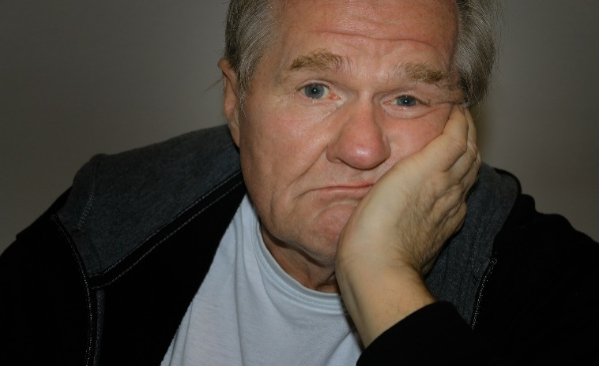 | Boredom | Green column
 | Having a quarrel | Red column  Or green if many quarrels
 | Job becomes too difficult to handle | Green column
 | Travelling
 | Relaxing/taking it easy | 3rd most common reason for AAWID
 | Hobbies
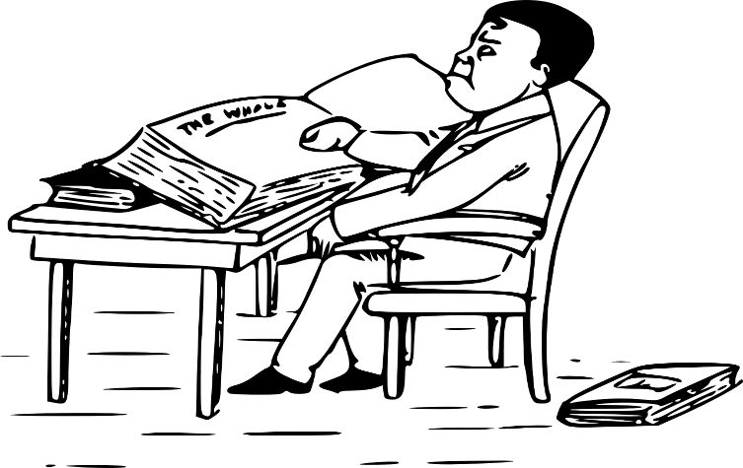 | Studying

