Exercise 7.2. Ways to keep in touch or reconnect with people

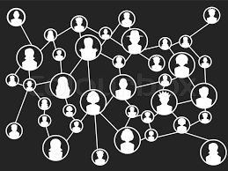

Content

How to re-connect with people……………………….…….…………..2

Activity 1: Ways to keep in touch.……………………....………….………...2

Activity 2: The story of Sam (part II)................................................2

Activity 3: Different devices to re-connect with people…..……………3

Annex 1:... (Available on the MNAM platform)

Annex 2:.............................................................................................4

How to (re-)connect with people

The activities aim to help AAWID think about ways to connect or reconnect with family and friends.

Note: This exercise builds upon participant’s knowledge of social media (see Unit 10).

Activity 1: Ways to keep in touch (10 min.)

Give each participant 2 post-its.

The question you should ask is: “Think about 2 ways to get into contact with people you love? Write your ideas on the post-it’s.

If this exercise is done individually, you may ask to AAWID to give as many ideas as possible.

If this exercise is done in group, ask each member to tell the group what they have written down. Let them stick their post-its on a flipchart or blackboard.

Meanwhile, also ask if the idea matches with the ideas of the other participants. If so, group these ideas together for them. When all ideas are on the flipchart, draw a circle around the matching ideas.

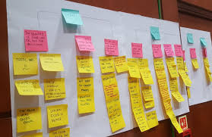

Activity 2: The story of Sam (part II)– questions (Annex 1 – ppt - 20 min.)

For this activity you need to show the PPT (Activity 2 – Annex 2- page 4). Start this activity by asking the participants what they still remember about the story of Sam. How did the story end? Now continue the story of Sam (Part II), or let them read the story themselves (see Annex 1 on the platform).

When reading the story about Sam part II, ask again the participants to listen carefully as they will need to answer some questions afterwards.

It is not a quiz this time. AAWID have to answer yes/no questions. Afterwards they need to explain their answer.
No
Yes

Educators have to help them to reflect about two things: 1. possible reasons why people cannot always meet as often as they wish to; and 2. others digital ways people can stay in contact.

Activity 3: Different devices to re-connect with people (Annex 2 – 20 minutes)

Print annex 2 (Next page). The aim of this activity is to learn which digital devices or social media platforms can be used to get in contact with family and friends. For each item, the participant needs to think if they can use it to write a text, to listen to them or see them.

We have used sclera pictograms, but pictures might be more suitable for some people.

 | Text | Call | See
Smartphone

UNIT 7 – Exercise 2 – Activity 3 – Annex 2

How are you able to use electronic devices or social media to get into contact with family or friends?

For example:

Sam would like to see his friend Jos every day.
Jos would visit Sam at the retirement home every other week.
During the other days Sam will use his smartphone to get into contact with Jos.
With his smartphone Sam can:

 | Text | Call | See
Smartphone

Now it is your turn.

On pages 2 and 3 you will see different devices.

They are shown in the left column.

Decide if with this device you can
- text someone
- call someone
- see someone

Devices | Text | Call | See
Letter
Email
SMS

Devices | Text | Call | See
Computer/notebook
Telephone
Tablet
Smartphone

Look at the following social media platforms and decide if these platforms allow you to text, call or see someone.

Social media | Text | Call | See
Facebook

WhatsApp
Twitter

Instagram

