**Exercise 1: Who is important in my life?**

**Afbeelding met muur

Beschrijving is gegenereerd met zeer hoge betrouwbaarheid**

Content

**Losing contact with family and friends**…….………….…....…..2

Activity 1: The story of Sam?.………….................…..…...……….……....2

Activity 2: Who did I lose contact with?...........................................3

Annex 1:...(Available on the MNAM platform)

Annex 2:.............................................................................................4

Losing contact with family or friends

This exercise is all about the process of ageing and events in a person’s life that lead to the loss of contact with a family member or friends. The activities mainly focus on helping AAWID to identify family members and/or other important persons they might have lost contact with during the course of their live, and with whom they wish to reconnect.

**Note:** the activities build upon the exercises of Unit 12, Who are the persons important to me?

Activity 1: The story of Sam – Quiz 1 (Annex 1 - 10 min.)

Start by telling and showing the story of Sam (see ppt annex 1 on the platform).

Afbeelding met hoed

Beschrijving is gegenereerd met zeer hoge betrouwbaarheid

Describe the activity to the participants and tell them there will be a small quiz at the end so they need to concentrate and listen carefully.

After the quiz, ask the participants if they themselves have moved to another place/home during the course of their lives. Ask them also if because of this move, they have lost contact with someone they liked or loved. Or maybe the other way around. Did someone important to them moved away? Like in the story of Sam, people might also lose contact because of the disputes. Also ask the participants if they might have lost someone due to fights or misunderstandings.

Activity 2: Who did I lose contact with? (Annex 2 – 30 min.)

For this activity let the participants draw up a storyline (life-line) see annex 2 (next page).

Begin by telling the participants the activity is to get them to think about all the persons that have been important to them in the course of their lives. Let them write down the names of these persons and or place pictures of these persons on the life-line (see below). Help them by thinking who was important when they were a child, when they went to school, when they started to work...

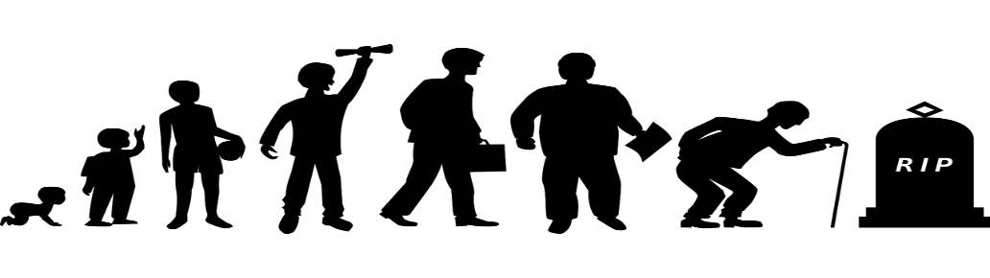

Tell the participants to draw a circle around the persons they would like to see more often and those they would like to reconnect with.

For each person, ask the participants to decide how often they would like to have contact with that person. They should fill in the worksheet – annex 2 (next page).

* Every day
* Few times a week
* Once a week
* Few time a month
* Once a month
* Few times each year
* One time each year

*Note: they will need the collage for the completion of the final exercise of Unit 7.*

Pictures used in this manual (and annex’s) have been downloaded from pixabay.com and sclera.be

UNIT 7 – Exercise 1 - Activity 2 – Annex 2

Afbeelding met hoed

Beschrijving is gegenereerd met zeer hoge betrouwbaarheid These are the persons that were important for Sam.

  Afbeelding met shirt

Beschrijving is gegenereerd met zeer hoge betrouwbaarheid 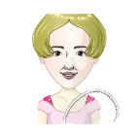 Afbeelding met speelgoed, pop

Beschrijving is gegenereerd met zeer hoge betrouwbaarheid 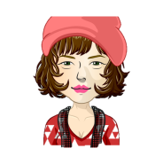   

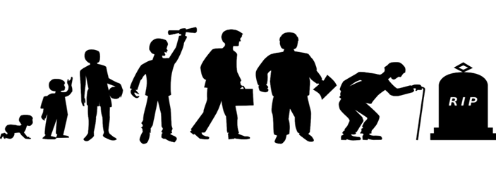

Who has been important to you in your life? Make your own collage or write the names.



Afbeelding met hoed

Beschrijving is gegenereerd met zeer hoge betrouwbaarheid This is how the persons are related to Sam.

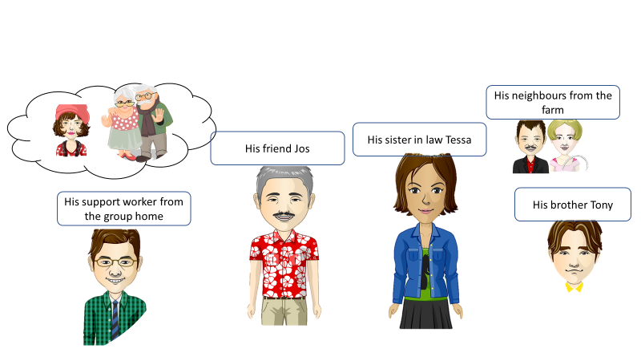

His wife Sophie and his parents but they died.

Afbeelding met hoed

Beschrijving is gegenereerd met zeer hoge betrouwbaarheid These are the people Sam used to see frequently but not anymore.

 Afbeelding met speelgoed, pop

Beschrijving is gegenereerd met zeer hoge betrouwbaarheid Afbeelding met speelgoed, pop

Beschrijving is gegenereerd met zeer hoge betrouwbaarheid

His sister-in-law Tessa

His brother Tony

His friend Jos

Who did you used to see regularly but not now anymore? *Draw a line under the names of those persons.*

Afbeelding met hoed

Beschrijving is gegenereerd met zeer hoge betrouwbaarheid These are the people Sam would like to see more often.



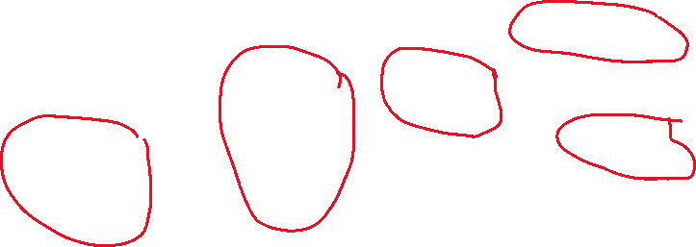

This is how often Sam would like to see those persons.

Jos = Every day Tessa = Once a week **Tony** = few times a month

 Afbeelding met speelgoed, pop

Beschrijving is gegenereerd met zeer hoge betrouwbaarheid Afbeelding met speelgoed, pop

Beschrijving is gegenereerd met zeer hoge betrouwbaarheid

Support worker His neighbours

from the group home = from the farm =

Once a month few times a year

Afbeelding met shirt

Beschrijving is gegenereerd met zeer hoge betrouwbaarheid Afbeelding met shirt

Beschrijving is gegenereerd met zeer hoge betrouwbaarheidAfbeelding met shirt

Beschrijving is gegenereerd met zeer hoge betrouwbaarheid

Who are the persons you would like to see more often or who would you like to reconnect with?

How often would you like to see them?