Exercise 6.4. Economic abuse

Claudia´s tutor has told to her she needs a new wheelchair and the tutor is going to withdraw some money from Claudia´s account. The days are passing and Claudia notices that she does not get the wheelchair. A month has passed and she is still waiting it. Claudia asks about her wheelchair and the tutor answers her that they are sorry, but they had to spend the money buying a bicycle to be able to commute to see her.

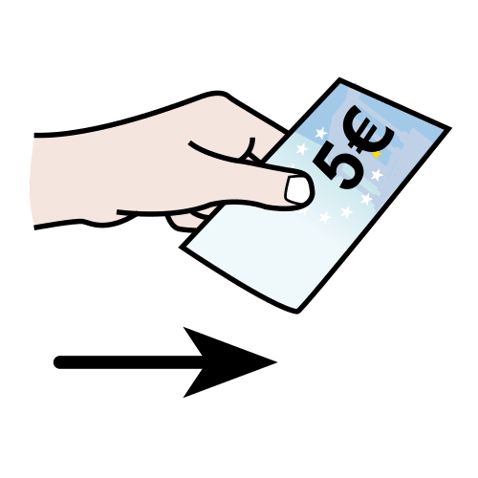

Which of these might be abusive conducts?

The educator exposes diverse situations to the AAWID and they should decide if they are –or not- abusive conducts. An interactive debate will follow it.

- Mario has asked to her tutor to withdraw money from his bank account to buy a TV set, because his is not working well. His tutor refuses his idea.

- Claudia has found out that her tutor has bought a motorcycle with her money. Her tutor has told her that they need it to visit her. Her tutor never asked her if she wanted to lend it to them.

- Claudia wishes to come out for lunch with a friend to celebrate her birthday. She needs money because she wants to treat her to dinner because they have not met up for a long time. She asks the money to her tutor and they give it to her.

Note: After identifying the abusive conducts, it seems appropriate to ask the learners to propose an adequate alternative.

