 

Exercise 6.3. Psychological abuse

Mario is taking part in a cognitive stimulation workshop organized by his residence. He likes it a lot and enjoy living in his residence. But today, a care-giver has been reviewing his work and has told him: “Mario, you seem dumb, you did it wrong again!”.

 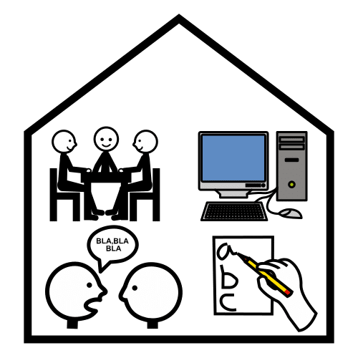

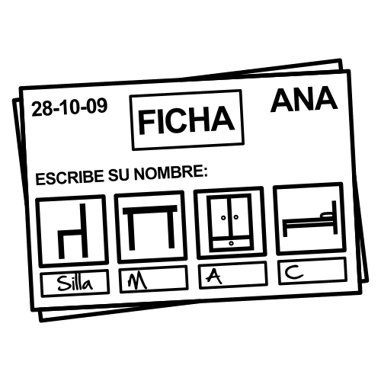 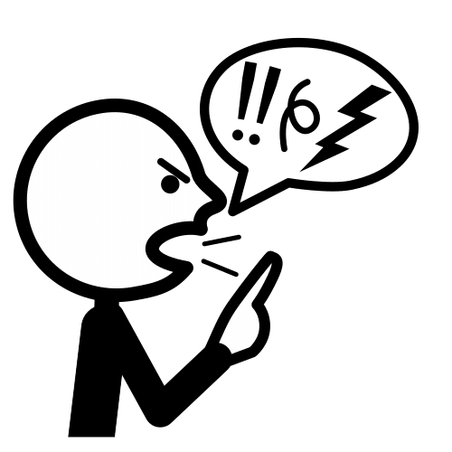

**Which of these might be abusive conducts?**

The educator exposes diverse situations to the AAWID and they should decide if they are –or not- abusive conducts. An interactive debate will follow it.

1. Mario helped himself a glass of milk on his home this morning. He dropped a little bit of milk over the worktop because he has hand tremors. His educator saw it and called him “clumsy”.
2. Claudia has difficulties to remember the persons´ names. She has run into a cleaning staff person today and when she was about to say hello to him, she got blocked. The person looked at her and said: “are you dumb, or what?
3. Mario tripped while walking using his walker and, accidentally, has thrown a bottle of water to the ground. His care-giver has helped him to get up and has said to him: “do not worry for the water”.

**Note:** After identifying the abusive conducts, it seems appropriate to ask the learners to propose an adequate alternative.