 

Exercise 6.2. Physical abuse

Maria is preparing herself to come out for dinner with their flatmates and her educator, as they do every Friday. It has become a little bit late, because Maria increasingly needs more time to dress up. The educator has got a little bit nervous, she has taken her arm and pulled off with undue force in order to make her leave her room.

  

 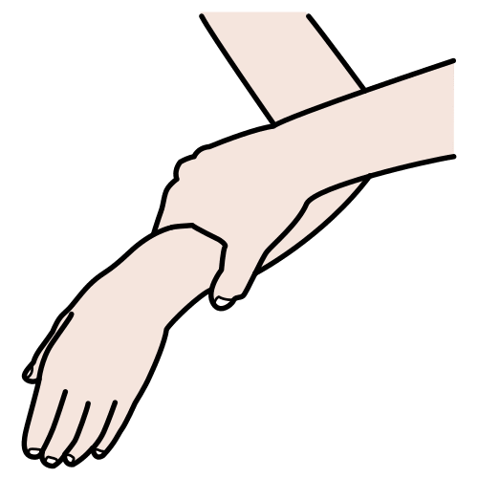

**Note:** After identifying the abusive conducts, it seems appropriate to ask the learners to propose an adequate alternative.

* **Which of these might be abusive conducts?**

The educator exposes diverse situations to the AAWID and they should decide if they are –or not- abusive conducts. An interactive debate will follow it, where examples of alternative correct conducts will be given to the AAWID.

1. Claudia uses the wheelchair in the shower and she gets support from a caregiver to be washed. Today, when she finished taking the shower, she had difficulties to get up and the care-giver took her arm and pulled off with undue force.
2. Mario needs sometimes support to eat because is having problems to coordinate the movement of his hand. Today, he got his face a little bit dirty and his care-giver noticed it. He has seated with him and has helped him to use the spoon.
3. Claudia is conducting a session of cognitive stimulation. She made a mistake in one exercise and her care-giver gave to her a soft pat on the head. Claudia got angry and her care-giver said to her: “Do not get angry, it was just a joke!”