Exercise 6.1. concept of "abuse" and types.

Activity 1. What does it mean "abuse"?

The first activity has been designed to be done in groups -or individually if educator believe that this subject can hurt the sensibility of any AAWID-, through the above open question.
Educator can use the images at the bottom of the page as support of this and the following activity.
In addition, educator can ask the AAWID the following questions:
- Has any kind of abuse behavior ever happened to you? What did you do? How did you feel?
- Do you know anyone who has been abused? Who abused him?

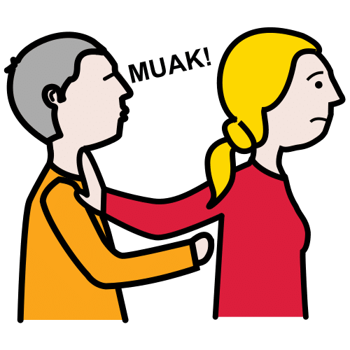

Activity 2. What types of abuse do you know?

This activity it has also been designed to work individually or by groups, reflecting and discussing about the above open question, in a way in which participants have to name the types of abuse they know (physical, sexual, psychological, economic, abandon….)

Educator will try that no abuse is left outside. It might be used visual supports bellow to list all types of abuse.

Note: This exercise might not be suitable for AAWID with previous experiences of abuse.

