Exercise 5.4. Quiz about ageing changes

This is a group or individual exercise. You will find 4 questions to ask the AAWID. If the answer is right, 1 point is achieved.

- What George should do to avoid to have physical problems and muscle pain?

 | A | To sit on the sofa and watch TV all day long.
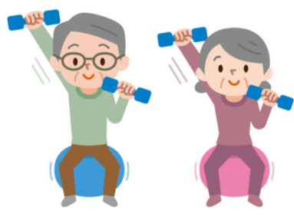 | B | To walk every day and do physical exercise.
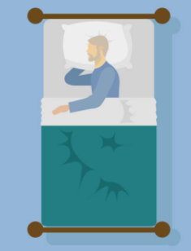 | C | To lie down on the bed.

- What type of food George should eat everyday to be healthy and have energy?

 | A | Chocolate and industrial pastries.
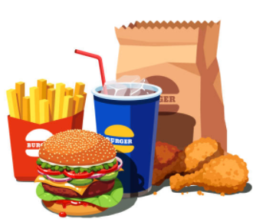 | B | Pizza and processed food
 | C | Vegetables, fruit, fish...
- Why George has to take medication and this is important for his health?

 | A | So having no pain neither complications in the future
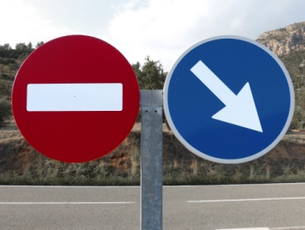 | B | Because he is forced to do so
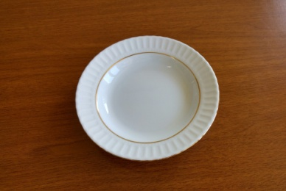 | C | Because in this way he will not be able to eat any more.

- What George has to do to avoid having heart, lungs or stomach problems?

 | A | To drink alcohol and smoke
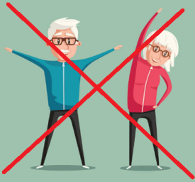 | B | Not doing exercises
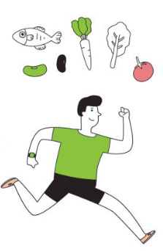 | C | To eat healthy and do exercises every day.

