Exercise 5.3. Ageing Concepts relation

In this exercise are shown a number of assertions that AAWID will have to classify by putting them on the green or red colour cardboard. The assertions related to the ageing process should be put on the green cardboard and those that not on the red cardboard. Likewise, they must reason why they correspond to one or another colour.

YES

NO

Following, are shown several examples of assertions.

* To be able to learn new things.



* To be really strong.
* To suffer from arthritis in the joints.

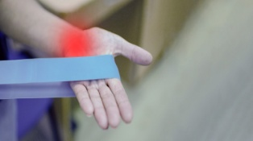 

* Not being tired/fatigued when climbing and descending stairs.



* To be able to run long distances.

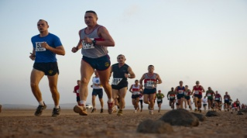

* Not having visionproblems.

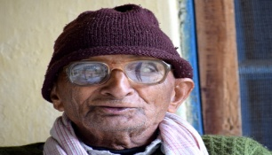

* To do physical exercises with friends.

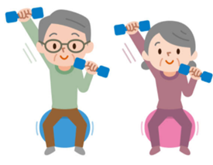

* To need dental prosthesis.



* To play games with my family

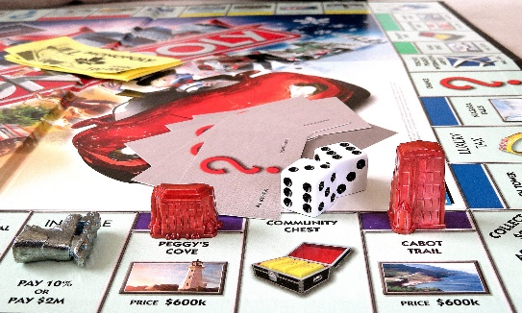

* To have balance problems.
* Memory loss.
* To walk in the park with friends.

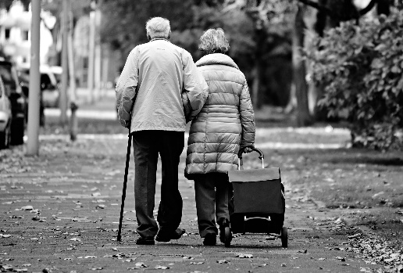

* To have sleep problems.

**Note:** the above assertions are only examples. They might be adapted or modified according to the AAWID level.