We are going to explain in this unit the changes that happen in the human being during the process of ageing. To be able to better involve the AAWID, we will introduce them to George, observing his evolution over time. In this way, we will be able to tell the most important ageing features and the process whereby George has passed until reaching the old age.

George´s story

**The young George**

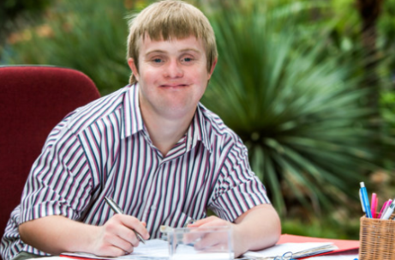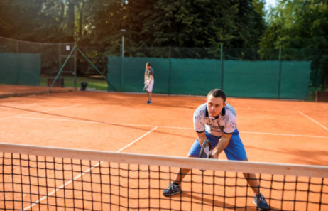

We here introduce the young George, he is a 30 years old, working as a helper in a concierge service in a school. He loves walking and playing tennis with his friends in his free time. He does not have any health problems, therefore, he does not take any medication.

**George nowadays**

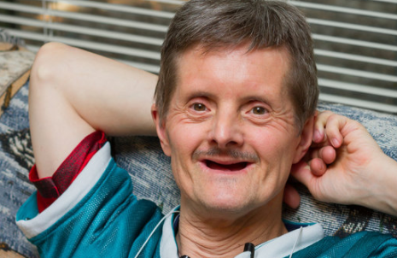

This is what George looks like nowadays. He is 70 years old and, how we can observe, his body and physical appearance has changed. He does not work anymore because he is retired. He no longer plays tennis in his free time and he must take medication because he is suffering from some diseases.

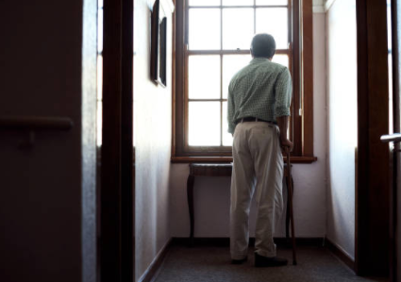

George is nowadays tired to play tennis, he does not like to go out so frequently as when he was younger. He feels sad sometimes and discouraged, preferring spend his time watching TV and not being with friends.

As a result of his age, George has discovered a number of changes in his body occurred over the years:

* His skin has become more fragile, less flexible, appearing wrinkles.

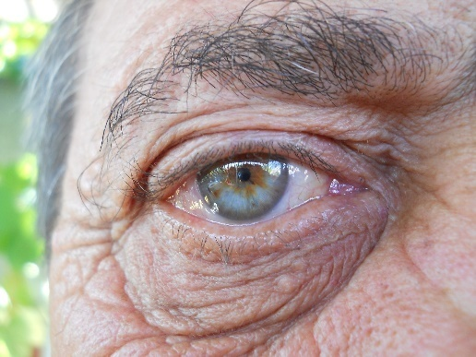

* His muscles and bones are not as they were before. They are nowadays weaker and have lost strength. He can not lift weight and has arthritic related problems.
* He is increasingly having problems to move himself and has balance problems, reaching the situation to fall down more than once.



* Her teeth have become more fragile and some of them have fallen out.



* He has seeing and hearing problems.
* He has trouble sleeping, he is increasingly tired during the day and less motivated to go out from home.
* He has heart problems, and high levels of cholesterol and blood pressure.
* He has breathing difficulties; he fatigues when he has to walk long distances or climb the stairs.
* He takes a large amount of medication.
* He has diabetes and must control de level of glucose in blood every morning.

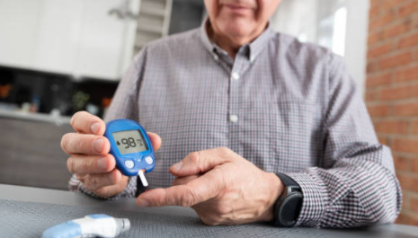

Exercise 5.1. What does it mean ageing to you?

Activity 1: The concept of ageing

In this introductory activity, educator might ask to the ageing adults with intellectual disabilities (AAWID), individually or by groups, what they understand from the concept of “ageing”. AAWID have to explain themselves the concept. The following questions and videos might help to start the debate:

Questions:

* Have you ever thought about the concept of “ageing"?
* Is ageing an important part of our life? Why?
* Is ageing good or bad?
* What will I be able to do when I get older?

Videos:

* <https://www.youtube.com/watch?v=yzbijwgtXBw> (subtitles accesible in several languages)
* <https://www.youtube.com/watch?v=VPIMiw3bPFo> (subtitles only in Spanish.

**Note:** It might happen that they do not understand the concept of ageing or are not able to explain it. For that purpose, educator can be supported by the previous questions and videos. The objective is to get familiar with the ageing process and with the fact that their body is going to change over time.

Activity 2: The meaning of ageing to you

Once the concept of ageing is being understood, educator might ask AAWID to reflect about:

1. The changes that they see in their parents since they were young until now.

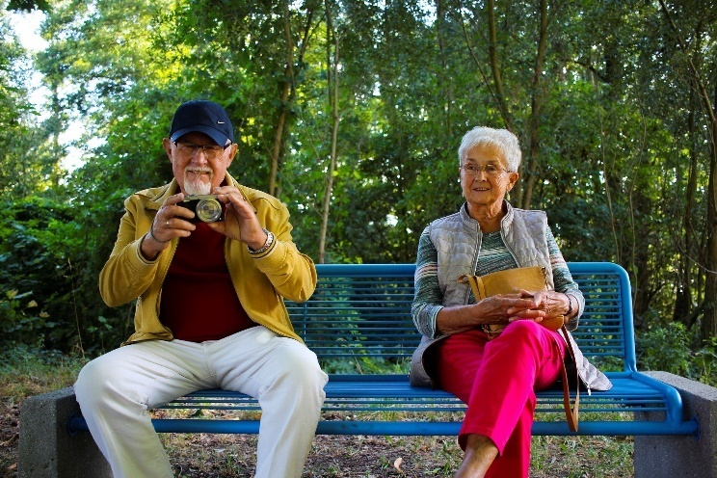

1. An example of a person who has got older. How do you feel when you see this person?
2. Will the ageing process happen to you? Is it happening now?
3. Is the ageing process equal for everyone?
4. What can we do to improve our happiness when we get older?