Exercise 4. True or false about healthy ageing.

Decide if the following statements are true or false.
 | Statements | True | False
 | It is good for Maria to eat more healthy food and less frozen food.
 | If Maria exercised more, she could avoid falling again.
 | At her age, Maria could begin boxing or playing rugby.
 | I can drink sugary drinks (cola) every day.
 | I can eat cakes every day.

 | Statements | True | False
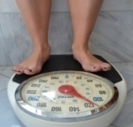 | I will lose weight if I eat more than I should or eat unhealthy food.
 | It is good to eat fruits and vegetables every day.
 | Old people should not exercise.
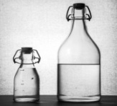 | I should drink 8-10 glasses of water per day.
 | It is good to go to bed very late and watch TV a lot.

