Exercise 3. Physical activity and its benefits.

Activity 3.1. Types of physical exercise suitable for ageing people.

In the table on the next page you can see 15 images of different physical activities.

Each participant should indicate in the corresponding box their opinion on the degree to which an exercise is suitable for people in the aging process (1. not appropriate; 2. somewhat appropriate; and 3. very appropriate).

To finish, the educator will carry out a debate in which they will share ideas and draw conclusions about which sports are more suitable at their age and which will be the most suitable in the future.

**Note:** It would be appropriate to print the table for this exercise, although it can also be done by using a screen or a digital whiteboard.

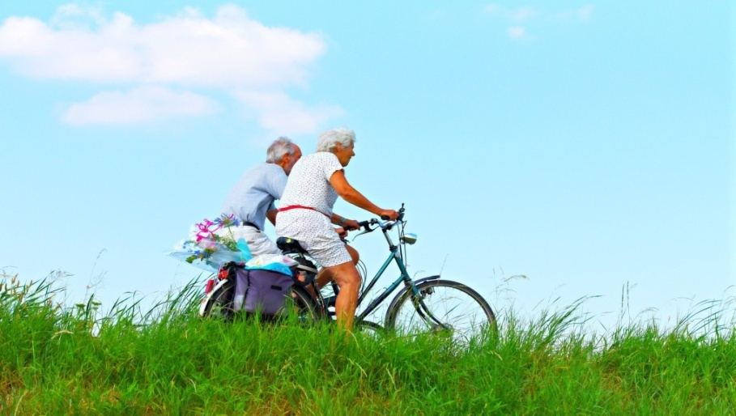

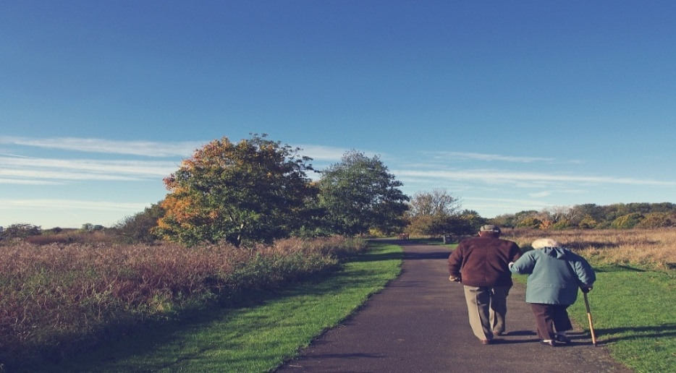

|  |  |  |  |  |  |  |  |  |  |  |  |  |  |  |
| --- | --- | --- | --- | --- | --- | --- | --- | --- | --- | --- | --- | --- | --- | --- |
| **Soft running** | | | **Swimming and exercising in a swimming pool** | | | **Basketball** | | | **Extreme mountain sports** | | | **Stationary bicycle** | | |
| Not appropriate | Somewhat appropriate | Very appropriate | Not appropriate | Somewhat appropriate | Very appropriate | Not appropriate | Somewhat appropriate | Very appropriate | Not appropriate | Somewhat appropriate | Very appropriate | Not appropriate | Somewhat appropriate | Very appropriate |
|  | | |  | | | C:\Users\USUARI\Downloads\basketball-102377_1280.jpg | | |  | | |  | | |
| **Yoga** | | | **Stretching** | | | **Going to the gym** | | | **Pétanque** | | | **Boxing** | | |
| Not appropriate | Somewhat appropriate | Very appropriate | Not appropriate | Somewhat appropriate | Very appropriate | Not appropriate | Somewhat appropriate | Very appropriate | Not appropriate | Somewhat appropriate | Very appropriate | Not appropriate | Somewhat appropriate | Very appropriate |
| Sin título | | | C:\Users\USUARI\Downloads\yoga-2662234_1920.jpg | | | C:\Users\USUARI\Downloads\machines-91849_1920.jpg | | | Sin título | | |  | | |
| **Dancing** | | | **Playing and exercising in a park** | | | **Walking in a park** | | | **Weight training** | | | **Rugby** | | |
| Not appropriate | Somewhat appropriate | Very appropriate | Not appropriate | Somewhat appropriate | Very appropriate | Not appropriate | Somewhat appropriate | Very appropriate | Not appropriate | Somewhat appropriate | Very appropriate | Not appropriate | Somewhat appropriate | Very appropriate |
| C:\Users\USUARI\Downloads\emotional-50309_1280.jpg | | |  | | | C:\Users\jose.gil\Downloads\women-3394510_1920.jpg | | | C:\Users\USUARI\Downloads\weights-79587_1920.jpg | | | C:\Users\USUARI\Downloads\rugby-1335770_1920.jpg | | |

Activity 3.2. Benefits associated with physical activity.

In table 2 -next page- you can see 6 types of benefits associated with physical exercise.

First, the educator will ask participants to reflect upon the potential benefits of physical exercise and sport for 10 minutes, either individually or in groups.

In the debate, participants can express either orally or in writing. If you choose the written mode, you can print the sheet on the right.

When the reflection is finished, you can show table 2 either printed or on a digital screen.

Each of the benefits of physical exercise is explained below. You can share results together to check whether all exercises shown in the table have been included. It would also be appropriate to see if participants can think of others that are not included in the table.

|  |
| --- |
| **Benefits of physical activity** |

|  |  |  |
| --- | --- | --- |
| **Table 2. Benefits of exercising** | | |
| **Benefit 1.**  It strengthens your bones.  Lower risk of fractures. | **Benefit 2.**  Stronger and more flexible muscles and joints. | **Benefit 3.**  It makes you feel better/you can do more things/it improves your self-esteem/it improves your memory/ more social relationships and friends/you can travel |
| C:\Users\USUARI\Downloads\skeleton-778117_1920.jpg | C:\Users\USUARI\Downloads\man-641691_1920.jpg | C:\Users\USUARI\Downloads\people-2583943_1920.jpg C:\Users\USUARI\Downloads\old-couple-2261495_1920.jpg C:\Users\USUARI\Downloads\hand-1008103_1920.jpg |
| **Benefit 4.**  It helps prevent diseases. | **Benefit 5.**  It improves balance and prevents falls. | **Benefit 6.**  It avoids heart problems. |
| C:\Users\USUARI\Downloads\grandmom-5103358_1920.jpg | C:\Users\USUARI\Downloads\smurf-2057239_1920.jpg | C:\Users\USUARI\Downloads\love-1520472_1920.jpg C:\Users\USUARI\Downloads\blood-pressure-monitor-1749577_1920.jpg |

Activity 3.3. What sort of physical exercise would you recommend to Maria? How would she benefit from it?

This exercise can be done individually or in small groups. You can print the tables on the right and the table on the following page, or they can be projected on a screen.

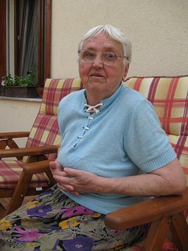

Do you remember Maria? We saw her story in exercise 1 of this unit.

The educator can open a debate where participants should choose 2 types of physical activity that they would recommend to Maria, and how Maria would benefit from them.

The exercise can end with a discussion, asking participants what sort of physical activity they currently practise, what sort of exercise they plan to do in the future and how they will benefit from them.

|  |  |
| --- | --- |
| **Please mark with a cross 2 types of physical exercise that you would recommend to Maria** | |
| Soft running |  |
| Swimming and exercising in a swimming pool |  |
| Playing and exercising in a park |  |
| Walking in a park |  |
| Stationary bicycle |  |
| Yoga |  |
| Stretching |  |
| Going to the gym |  |
| Pétanque |  |
| Dancing |  |
|  | |
| **Please mark with a cross the statements that explain how Maria would benefit from physical exercise** | |
| Her bones would be stronger. |  |
| Her muscles would be stronger and more flexible. |  |
| She would be happier. |  |
| She could do more things: walking for longer, carrying her shopping bag, meeting her friends for a coffee. |  |
| Her memory would improve. |  |
| She would have a better balance and would not fall again. |  |
| Her heart would be stronger. |  |
| She would have fewer diseases. |  |
| She would be able to travel with her friends. |  |
| All of the above. |  |

|  |  |  |  |  |
| --- | --- | --- | --- | --- |
| **Soft running** | **Swimming and exercising in a swimming pool** | **Playing and exercising in a park** | **Walking in a park** | **Stationary bicycle** |
|  |  |  | C:\Users\jose.gil\Downloads\women-3394510_1920.jpg |  |
| **Yoga** | **Stretching** | **Going to the gym** | **Péthanque** | **Dancing** |
| Sin título | C:\Users\USUARI\Downloads\yoga-2662234_1920.jpg | C:\Users\USUARI\Downloads\machines-91849_1920.jpg | Sin título | C:\Users\USUARI\Downloads\emotional-50309_1280.jpg |

|  |  |  |
| --- | --- | --- |
| **Table 2. Benefits of exercising** | | |
| **It strengthens your bones.**  **Lower risk of fractures.** | **Stronger and more flexible muscles and joints.** | **It makes you feel better/you can do more things/it improves your self-esteem/it improves your memory/ more social relationships and friends/you can travel** |
| C:\Users\USUARI\Downloads\skeleton-778117_1920.jpg | C:\Users\USUARI\Downloads\man-641691_1920.jpg | C:\Users\USUARI\Downloads\people-2583943_1920.jpg C:\Users\USUARI\Downloads\old-couple-2261495_1920.jpg C:\Users\USUARI\Downloads\embrace-4788167_1920.jpg C:\Users\USUARI\Downloads\hand-1008103_1920.jpg |
| **It helps prevent diseases.** | **It improves balance and prevents falls.** | **It avoids heart problems.** |
| C:\Users\USUARI\Downloads\grandmom-5103358_1920.jpg C:\Users\USUARI\Downloads\old-83952_1280.jpg | C:\Users\USUARI\Downloads\smurf-2057239_1920.jpg | C:\Users\USUARI\Downloads\balloon-991680_1920.jpg C:\Users\USUARI\Downloads\love-1520472_1920.jpg C:\Users\USUARI\Downloads\blood-pressure-monitor-1749577_1920.jpg |