Exercise 2. Playing with the food pyramid

The educator will help participants to design a food pyramid either in groups or individually. The pyramid should have 7 sections -a, b, c, d, e, f, g-.

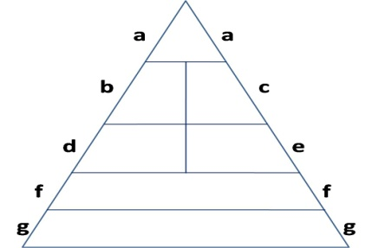

To do this, participants must choose a food type for each section of the pyramid. They will use 19 out of the 24 included in the following table.

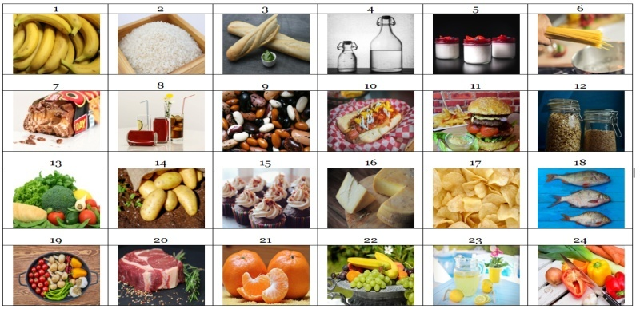

The other 5 food types (a hamburger, crisps, a chocolate bar, a hot dog and sugary drinks) should be crossed out of the menu because they are unhealthy food. They will be left out of the pyramid.

At the end of the exercise, the pyramid should be complete with the corresponding numbers or the name of the food types, as shown in the two following images.

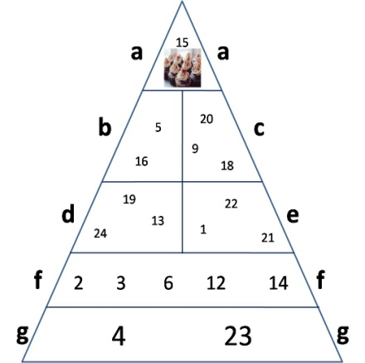 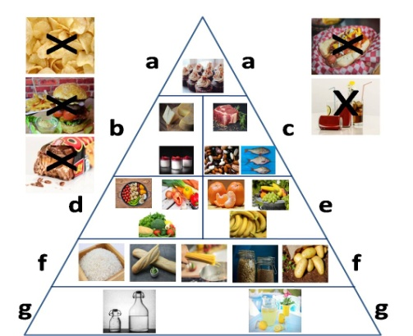

You can finish the exercise by discussing the following questions with participants:

* Why are there more food types at the bottom sections of the pyramid, and only 1 in the top section?
* What 5 food types have we discarded? Why?
* Could you find more examples of unhealthy foods like the 5 we have discarded? How many unhealthy foods have you eaten in the last week?

**Note:** The tables and figures shown on this page are included in bigger size on the following pages.

**Steps:**

**1**. The exercise can begin with these 2 examples:

1. As shown in the table, food number 15 -cakes- should be put in section a, at the top of the pyramid, because it is a food that should rarely be eaten.
2. Food number 7 –chocolate bars- is one of the 5 foods that we cannot use and that must be crossed out because it is not healthy. The table includes 5 food types that are not healthy, and that we will try to identify at the end of the exercise.

**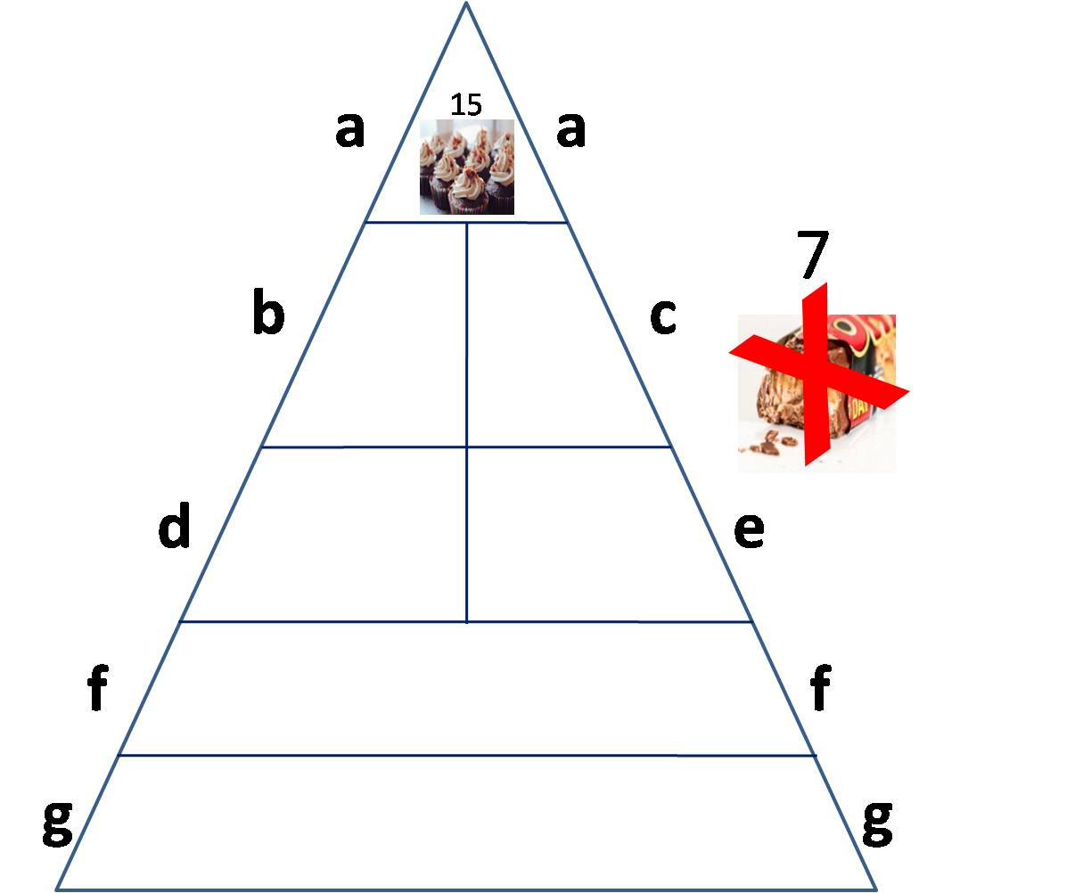**

**2.** We are now going to look for the 2 food types that go in section b (yogurt and cheese).

**3.** Now, we are going to look for the 3 food types that should go in section c (fish, meat and beans).

**4.** We will now search for 3 images of vegetables that go in section d.

**5.** Now, we will search for 3 images of fruits, which will go in section e.

**6**. We are now going to search for the 5 food types that go in section f (bread, rice, cereal, pasta and potatoes).

**7.** Search for 2 drinks without any added sugars (water and lemonade) that will go in section g, at the bottom of the pyramid.

**8.** Last, search for the 5 unhealthy food types that should be crossed out and remain out of our pyramid and of our ideal menu (hamburger, chocolate bar, crisps, hot dog and sugary cola drink).

**9.** Debate.

Below you will find the completed pyramid and the table with the 5 foods that must be crossed out. Examples and unresolved templates are on later pages for participants to fill out. Images can be printed.

**Note:** You can also print the pyramid and food types, cut them out and have users put each food type in the corresponding section of the pyramid.

**correct answers**

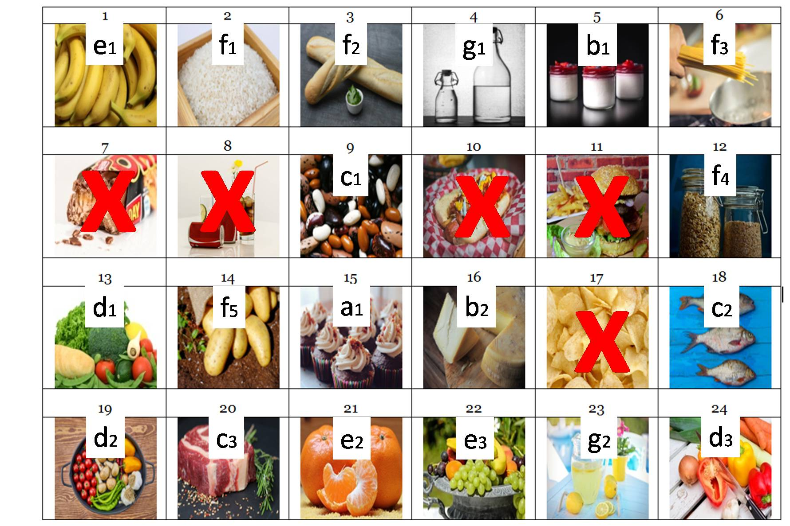

**Correct answers**

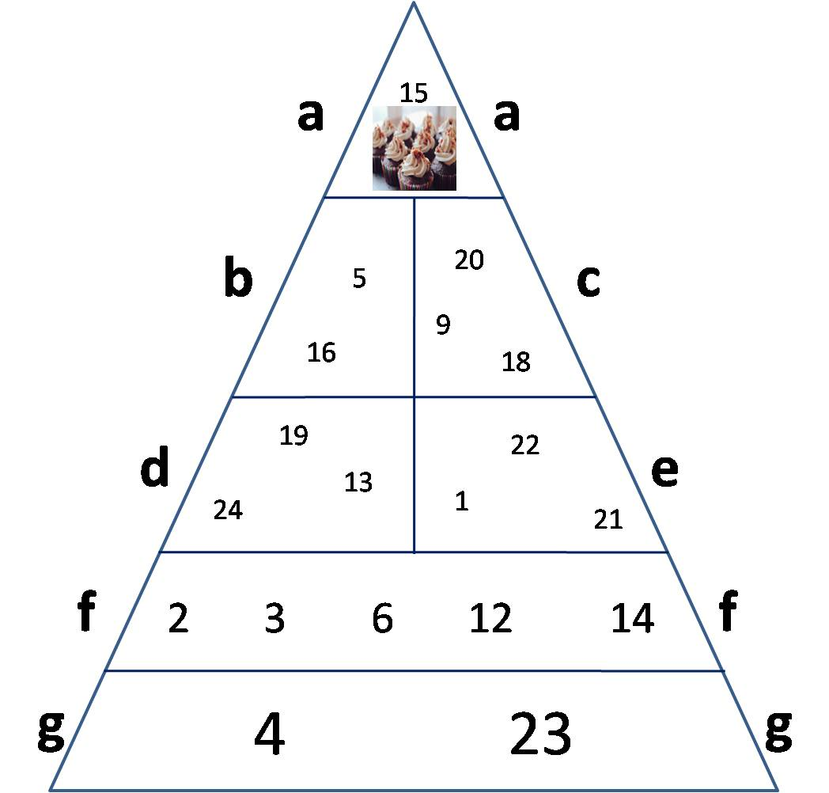

**Example to teach the exercise to participants**



**Example to teach the exercise to participants**

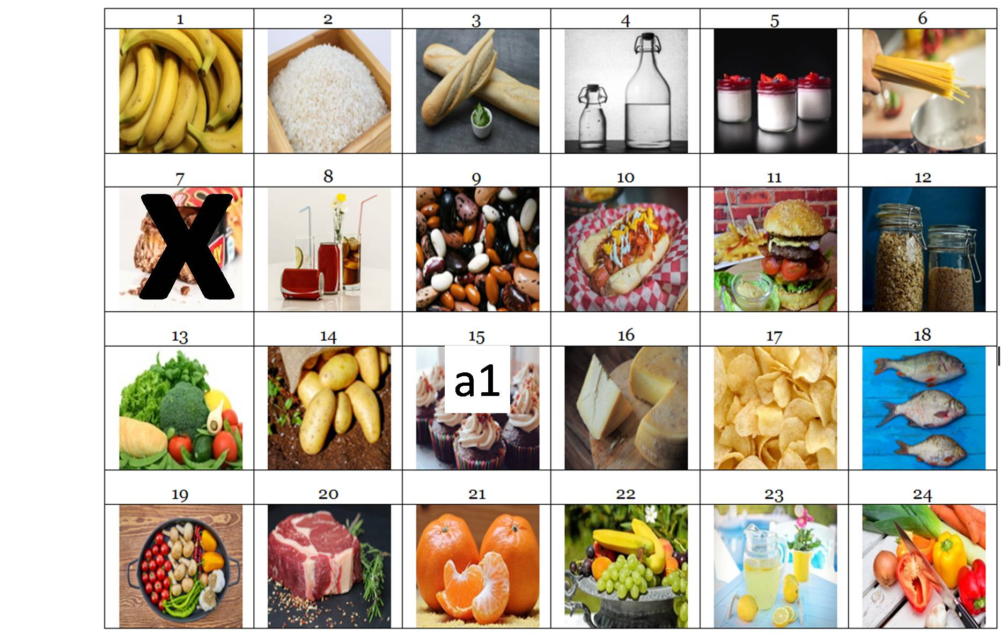

**Table 1 can be printed or shared on a screen. Participants can do the pyramid based on these food types.**

|  |  |  |  |  |  |
| --- | --- | --- | --- | --- | --- |
| **Table 1. Food types** | | | | | |
| 1 | 2 | 3 | 4 | 5 | 6 |
| C:\Users\jose.gil\Downloads\bananas-3700718_1920.jpg |  |  | C:\Users\jose.gil\Downloads\water-bottle-2001912_1920.jpg |  |  |
| 7 | 8 | 9 | 10 | 11 | 12 |
| C:\Users\jose.gil\Downloads\chocolate-bar-1636220_1920.jpg | C:\Users\jose.gil\Desktop\sugar drinks.jpg |  | C:\Users\USUARI\Downloads\hot-dog-5337929_1920.jpg | C:\Users\USUARI\Downloads\burger-3962997_1920.jpg | C:\Users\USUARI\Downloads\cereals-1236202_1920.jpg |
| 13 | 14 | 15 | 16 | 17 | 18 |
| C:\Users\jose.gil\Downloads\vegetables-1238252_1920.jpg |  |  |  | C:\Users\USUARI\Downloads\chips-potatoes-1418192_1920.jpg |  |
| 19 | 20 | 21 | 22 | 23 | 24 |
|  |  | C:\Users\USUARI\Downloads\tangerines-1721633_1920.jpg |  | C:\Users\USUARI\Downloads\lemonade-3571083_1920.jpg | C:\Users\USUARI\Downloads\vegetables-573958_1920.jpg |

**Empty pyramid to be printed or projected on a screen for the group to do the exercise**

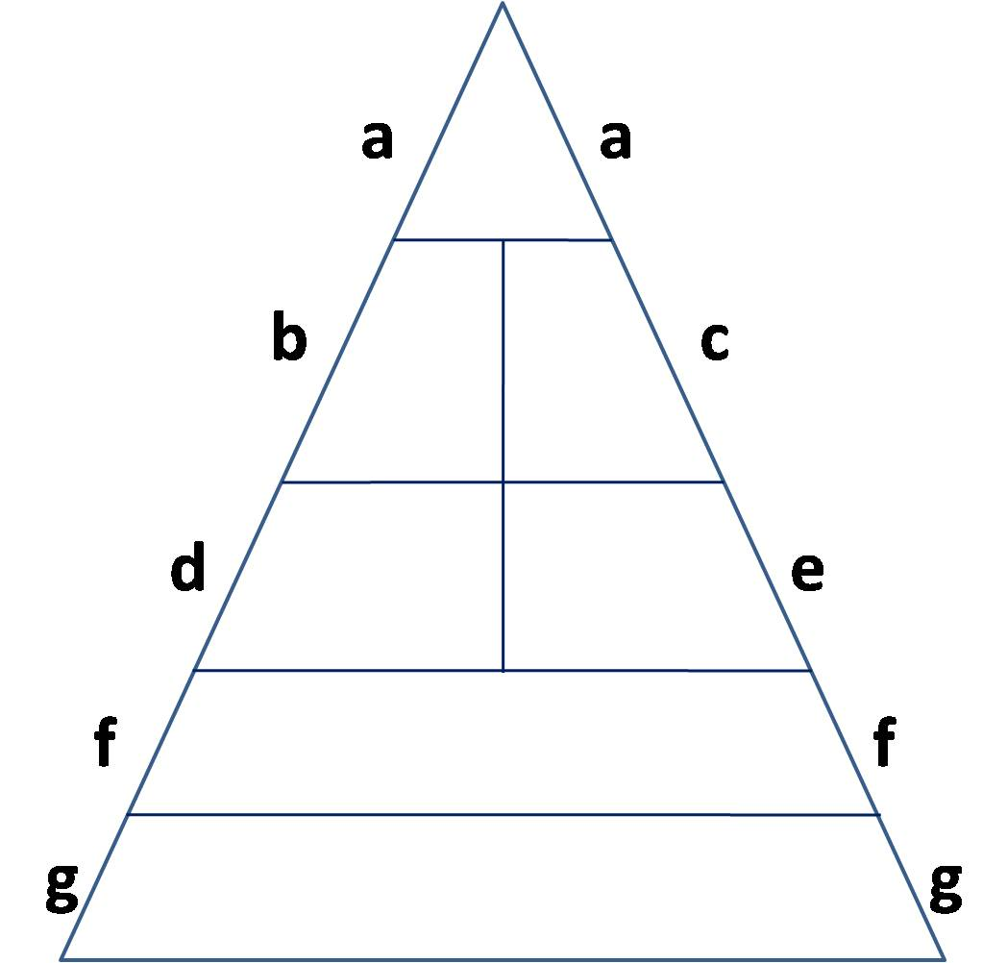

**Final pyramid with food types**

