Exercise 1. Improving Maria’s health

If we want to age with a good quality of life, we should develop certain habits and have a healthy lifestyle.

In this unit, we will practise with some exercises which aim at helping us grow old with a good quality of life.

Maria’s story

Maria is a 70-year-old woman who lives alone.

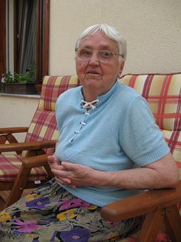

Ever since she retired, her life has been changing. Maria notices that she is gradually losing her ability to stay active and do things.

Maria no longer has obligations and gets up late in the morning. She does not eat any breakfast and does not feel like doing any household chores.

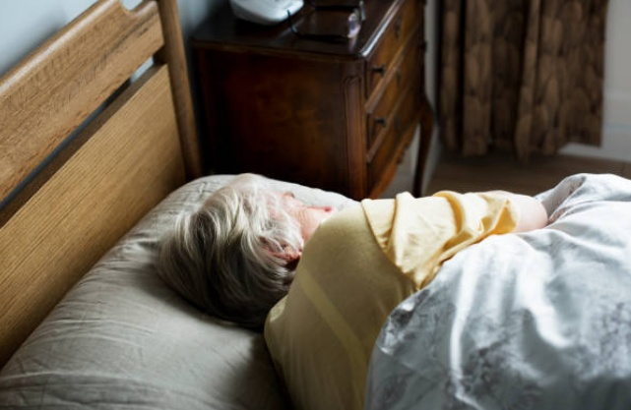

She prefers a cleaning person to do the housework for her.

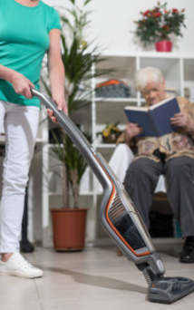

Maria used to go for a coffee…

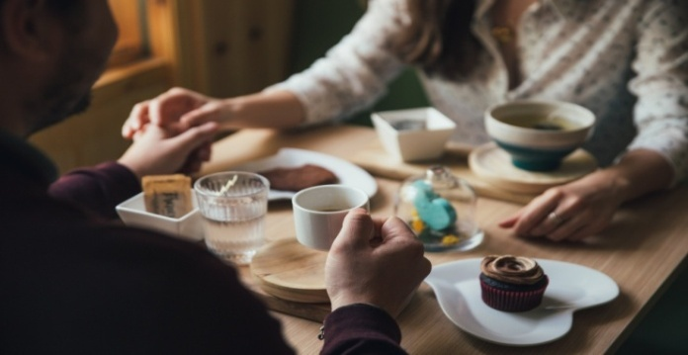

...and play cards with her friends every afternoon.

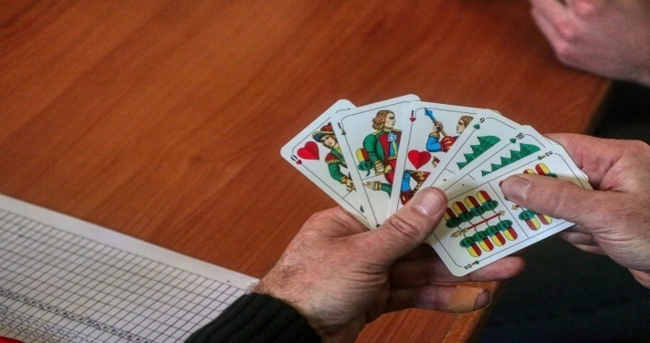

However, Maria hardly ever sees her friends anymore because she prefers to stay home watching TV.

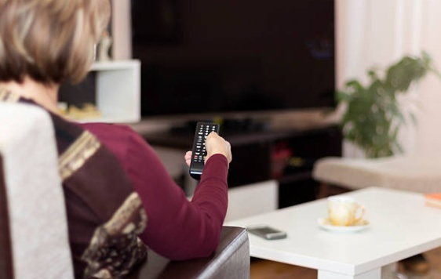

In addition, she feeds on frozen or prepared food because she does not feel like cooking.

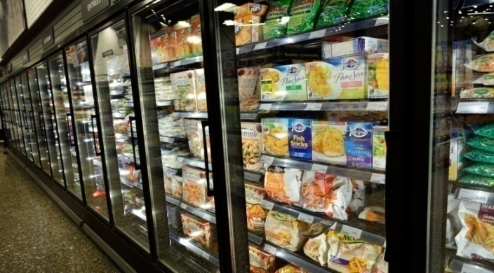

Lastly, Maria has changed her routine. She does not engage in any physical activities, and the last time she saw her doctor, he said that her health has deteriorated a lot and that she should take a bit more care of herself.

Activity 1.1. Improving Maria’s quality of life.

Once the participants know about Maria's story, the educator should open a debate about whether Maria is doing things correctly or whether she should change some aspects in her life.

The educator can begin the discussion by showing the pairs of pictures on the right and on the following page.

Once they have seen all the pairs of pictures, each participant should receive a sheet of paper (Figure 1) where they should write 2 activities that Maria could undertake to improve her quality of life and thus experience a healthier aging.

To finish, we will share the different suggestions of each participant and comment on the healthiest lifestyles.

**Figure 1. Healthy lifestyles**

|  |
| --- |
| **Healthy lifestyles**  Sin título |

|  |  |
| --- | --- |
| **HEALTHIER** | **LESS HEALTHY/UNHEALTHY** |
| **Physical activity and sports** | **Lack of physical activity** |
| C:\Users\jose.gil\Downloads\person-3553814_1920.jpg | C:\Users\USUARI\Desktop\Tv.jpg |
| **Not smoking** | **Smoking** |
|  | C:\Users\jose.gil\Downloads\smoker-798992_1920.jpg |
| **Healthy drinks: juices** | **Unhealthy drinks: sugar-sweetened soft drinks** |
| C:\Users\jose.gil\Downloads\smoothies-2253430_1920.jpg | C:\Users\jose.gil\Desktop\sugar drinks.jpg |

|  |  |
| --- | --- |
| **HEALTHIER** | **LESS HEALTHY/UNHEALTHY** |
| **A healthy and varied diet** | **Processed foods with low-quality ingredients and high in fat** |
| C:\Users\jose.gil\Downloads\food-2569257_1920.jpg | C:\Users\jose.gil\Downloads\hamburger-2683042_1920.jpg |
| **Drinking water: 2 l per day** | **Drinking alcohol** |
| C:\Users\jose.gil\Downloads\water-bottle-2001912_1920.jpg | C:\Users\jose.gil\Downloads\woman-3319540_1920.jpg |
| **Going out for walks with friends** | **Staying bored at home** |
| C:\Users\jose.gil\Downloads\women-3394510_1920.jpg | C:\Users\jose.gil\Downloads\brown-5186747_1920.jpg |

|  |  |
| --- | --- |
| **HEALTHIER** | **LESS HEALTHY/UNHEALTHY** |
| **Fresh food: fish and vegetables** | **Industrial sweets and pastries** |
| C:\Users\jose.gil\Downloads\food-865102_1920.jpg | C:\Users\jose.gil\Desktop\caramelo.jpg |
| **Learning new things: painting** | **Doing nothing** |
| C:\Users\jose.gil\Downloads\man-505353_1920.jpg | C:\Users\jose.gil\Downloads\man-272675_1920.jpg |
| **Showering and grooming frequently** | **Not showering or washing (lack of personal hygiene)** |
| C:\Users\jose.gil\Downloads\ducha.png C:\Users\jose.gil\Downloads\peine y tijeras.png | C:\Users\jose.gil\Downloads\hands-2763537_1920.png |

Activity 1.2. Making a menu for Maria.

A proper nutrition is a very important habit for a good health. When people grow old, they tend to eat in a way they do not need, just like we have seen in Maria’s story. She does not cook anymore and feeds on frozen and prepared foods at random times.

For this reason, we are going to help Maria by making a menu for two days (it must include breakfast, lunch and dinner) and establishing a schedule for her meals.

We suggest that the activity be carried out in small groups of participants.

The educator can use the tables and the food pyramid specific for older people that can be found on this page and on the next.

|  |  |  |
| --- | --- | --- |
|  | **Food** | **Portions** |
| **1.**  Sweets and fats | C:\Users\jose.gil\Downloads\chocolate-bar-1636220_1920.jpg | Never/Rarely |
| **2.**  Milk, yogurt and cheese |  | 3 portions |
| **3.**  Fish, meat and beans |  | 2 portions |
| **4.**  Vegetables | C:\Users\jose.gil\Downloads\vegetables-1238252_1920.jpg | 3 portions |
| **5.**  Fruits | C:\Users\jose.gil\Downloads\bananas-3700718_1920.jpg | 2 portions |
| **6.**  Bread, cereal, potatoes, pasta |  | 6 portions |
| **7.**  Water | C:\Users\jose.gil\Downloads\water-bottle-2001912_1920.jpg C:\Users\jose.gil\Downloads\water-bottle-2001912_1920.jpg | 8 glasses |

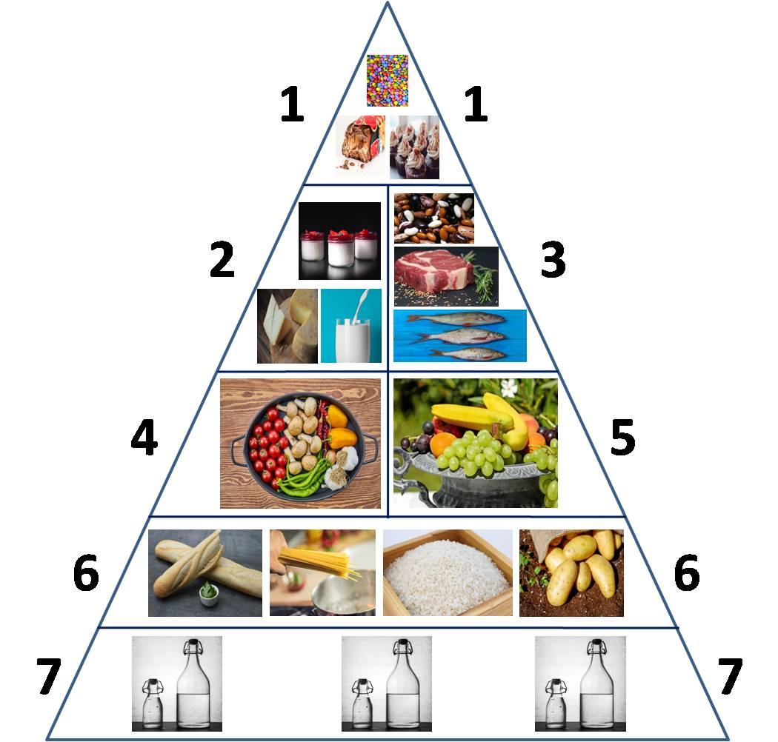

To make Maria's menu, the numbers of the pyramid and the chosen food type must be included in the following tables.

|  |  |  |  |  |  |
| --- | --- | --- | --- | --- | --- |
| **Day 1** | |  | **Day 2** | | |
| Breakfast | | Breakfast | | |
| Time |  | Time |  | |
| Numbers |  | Numbers |  | |
| Menu/Dishes |  | Menu/Dishes |  | |
| Lunch | | Lunch | | |
| Time |  | Time |  | |
| Numbers |  | Numbers |  | |
| Menu/  Dishes |  | Menu/Dishes |  | |
| Dinner | | Dinner | | |
| Time |  | Time | |  |
| Numbers |  | Numbers | |  |
| Menu/Dishes |  | Menu/Dishes | |  |

To finish with the exercise, a debate can be opened to check the numbers they have used and whether the proportions are okay.