Exercise 3.8. Organizing my documents

Activity 1. Gathering information.

We will begin the activity by gathering information on whether or not they store their documents and how they do so.

- Do you keep all the letters from your bank? Where?
- Do you keep all your payrolls? Where?
- Do you keep all your pension papers? Where?
- Do you keep all the tickets of your purchases? Where?

We will complement this activity with a practical exercise to reinforce the importance of keeping all documents always in the same place and in an orderly manner.

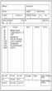
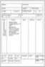
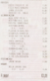
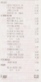

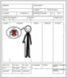

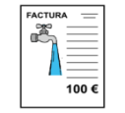
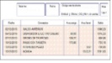

Note: It is recommended to do this exercise individually. Some AAWID may not be willing to comment on their financial situation within a group.

Activity 2. Organizing the documents.

We will tell the participants to bring their income and expense documents so that we can organize them in folders. If it is not possible to have their documents, we will provide them to them and will help them create their personal folders with the necessary support so that they can carry out the task as independently as possible.

Note: Participants may not identify the different types of documents, so we will explain what each of these documents is. This activity can be adapted by assigning each type of document a folder colour, having a template where we will put the photo of each document associated with the colour of its folder, etc.

Income folder
(Payrolls and pension)

Bank folder

Expense folder (Purchases)

Invoice folder
(Electricity, water, insurances, …)

