Exercise 3.5. Identifying my balance

Aging adults with intellectual disabilities have a hard time understanding balance, balance types, and whether or not they can spend more money.

The educator will ask the group to answer the 3 questions below. Each member of the group can contribute their own ideas and, after that, the following concepts will be defined all together (educator + AAWID):

- What is balance?
- What types of balance are there? (Positive, zero balance, negative)
- Do you know what your balance is?
Note: These definitions should be written somewhere visible to all (such as a board) so that we can check them whenever it is needed and are able to do the following exercises.

Note: Remember that many people with intellectual disabilities do not know how to perform mathematical operations, so we will have to look for help and adapt the exercise to the knowledge of each of the members of the group. Templates, calculators, real coins, etc. can be used.

In order to consolidate the concept of balance, the educator will carry out the following practical activities:

Identify the types of balance of these amounts of money:

BALANCE | TYPES OF BALANCE
- 85  0  50  - 6  - 20  120  0  35 | Positive balance  Zero balance  Negative balance
We will now check Philip’s balance. For that, we have to write down Philip’s income and expenses in the following table and then subtract them to know how much money he has left. Once the operation has been carried out, we will analyze Philip’s balance.

Income

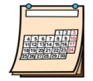
Expenses

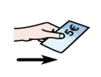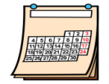
Balance
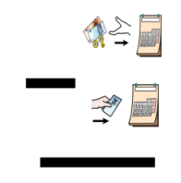

This same activity will be carried out with the income and expenses of each of the group participants analyzing what their balance is.

