Exercise 3.2. What concerns me about money?

AAWID -individually or by group- are invited to reflect on their own economic situation, focusing on how to optimize the income and the spendings when they get older. Some examples to reflect could be:

* Who will take care of me?



* Will I need to move to other accomodation? Will I be able to aford it?

|  |  |  |
| --- | --- | --- |
| **Residence for the elderly** | **Residence for people with disabilities** | **Own housing** |
| Residencia de ancianos | Residencia para personas con discapacidad | vivienda propia |

* Who will help me with money management? (family members, caregivers, friends...)

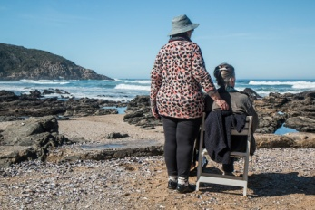 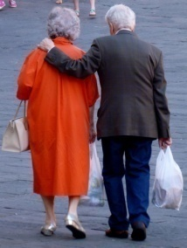

* Will I have enough money to cover my new needs?



Once AAWID has expressed their concerns, the educator will search for potential solutions such as talking to his/her family members about those concerns, seeking help from others, etc.

Finally, the educator is suggested to focus on the right of the person to decide how to manage his/her own money. He/she will open a debate.

**Reflection and debate:** Do I have the right to manage my own money?