Philip's story

The educator can start this exercise and the following by telling the story of Philip (it can be read in group or individually).

Philip is 55 years old and works at a gardening company.
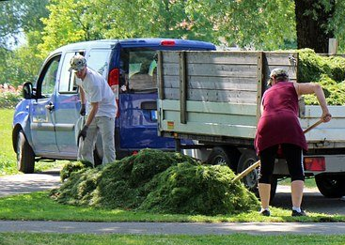

Philip at work

He lives with his girlfriend, near his mother's house.

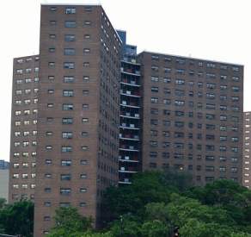

Philip's mother helps them in everything they need, especially in money management. However, his mother is very old and in poor health, and sometimes she cannot help them.

Philip’s mother

Philip is concerned that no one could help him with money management when his mother passes away.

His sister is married and has two children, and he does not want to be a burden to her. Besides, she lives far from Philip and he does not want to leave his house to go live in a residence or with his sister.

Philip’s sister with her
husband and children

He is also concerned about his health and his girlfriend's.

He does not know how much money he is going to need when he is older. He thinks he will need more money for other things in the future, or that he might have to stop doing some things he likes because he does not have enough money.

Philip has many doubts and concerns about his financial future (economic needs in a few years’ time), what
he will need when he gets older, who is going to
help him with money management, how much money
he will need, etc.
Exercise 3.1. What new needs do older people have?

In this activity, each member of the group will say what they think about what their needs are going to be when they grow older. It is essential not to forget important aspects such as assistance with activities of daily living, health issues (mobility, sensory loss, memory, more medicines, special diets…), more money for hygiene products, paying someone to help them, other leisure activities, etc.

Each of the needs that are said can be written on a board and then discussed in more depth.

Once we have a list of new needs, each group member can write on a piece of paper the ones that they believe may be their own needs according to their personal circumstances.

Note: It needs to be borne in mind that many people with intellectual disabilities are not aware of their economic situation. For some, their needs are usually related to leisure activities and they do not manage the money to cover other basic needs such as food, electricity, water, rent, medicines, etc.

These images can help us discover new needs:

Dentist (Dental problems) | Oculist (Vision problems)
 | 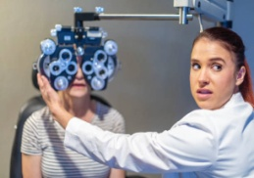

Medicines (New diseases) | Otologist (Hearing problems)
 | 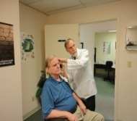
Support with money management: banks, documents, expenses.... | Support with activities of daily living: cooking, eating
Support with activities of daily living: getting dress | Support with activities of daily living: moving
Support with activities of daily living: personal hygiene and grooming | Support with activities of daily living: cleaning the house

