Exercise 2.6. True/False questions about adaptation, support products and assistive technology.

Please, decide if the following statements are true or false.
 | STATEMENTS |  | True | False
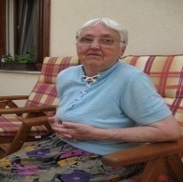 | Maria will have less need to use support products in the future. |  |  | 
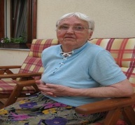 | As Maria lost track cooking, a kitchen chronometer could be very useful for her. | 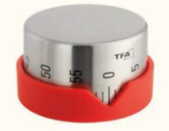
 | These buildings are suitable for elderly people to live in.
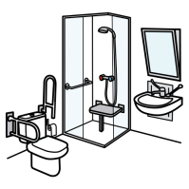 | This bathroom can be used by any kind of people of all ages.
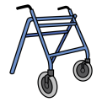  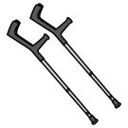 | I am never going to need any environment adaptation at home, either any support product.

 | STATEMENTS | True | False
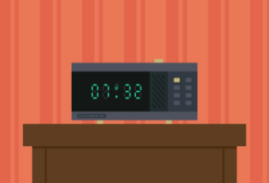 | It would do me well to have a speaking alarm clock because I get lost sometimes when I go out from home.
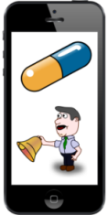 | As I forget to take the medication on occasion, It would be helpful to have a mobile phone application to alert me of when I have to take it.
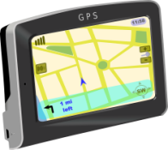 | As I sometimes get lost when I go out, It would be helpful to have with me or wear when I far from home a GPS tracker bracelet, a GPS pedestrian navigator or a GPS smart shoes/soles.

