Exercise 2.5. Matching assistive technology with its usefulness.

To do this exercise, the reader will find two tables with identical structure in the following two pages. Each table is formed by 3 columns. The two columns on the left side show a photo or picture of 9 assistive technological devises and their definition. The column on the right side shows several random options about the potential usefulness of these products to improve the quality of life of AAWID. -A technological product might have several uses".

The educator might start the exercise describing the first technological product -GPS tracker bracelet-. Following, a debate can be started to let AAWID to reflex and match this product with its possible usefulness, as it can be on the right part of this page. Educator can do the same with the rest of the products.

Note: It has to be highlighted that assistive technology is advancing a lot and each country might have different tools or specific apps. Therefore, educators should to get advice to know which updated tools are available on the market, if they are free of charge or on a fee-paying basis, adaptable to different users, etc.

Non-real example of matching.

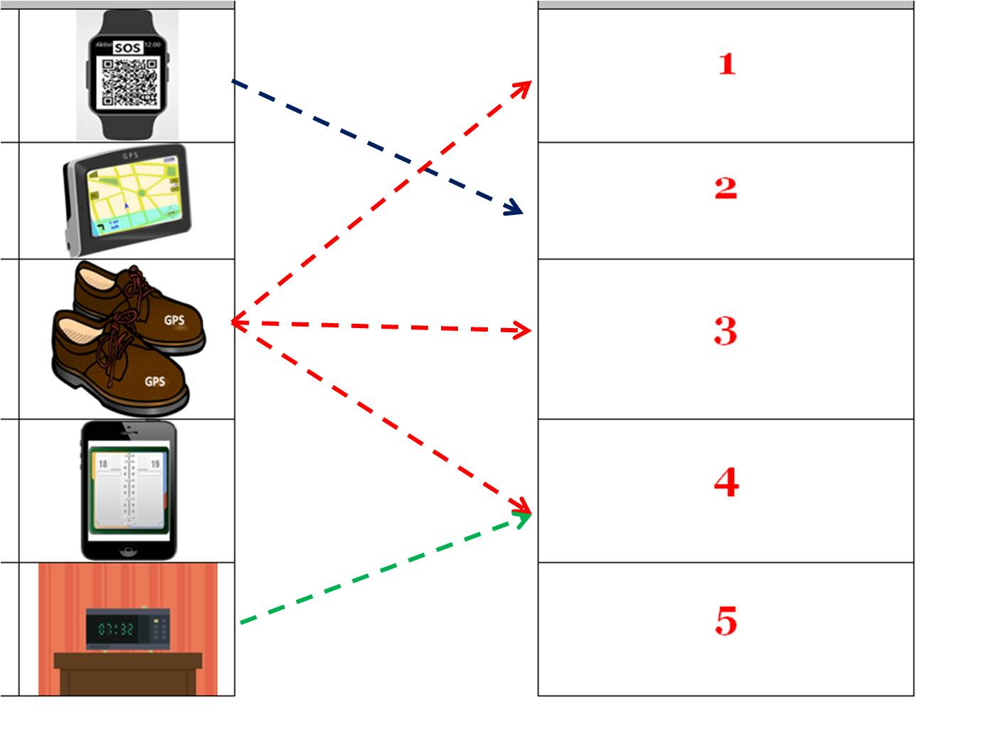

Assistive technology |  |  |  | Match each product with its usefulness. |  |  | It could help me if...
GPS tracker bracelet which has a laser engraved QR code, including health and personal data to use in case of emergency. |  |  |  |  |  |  | 1  ... I have problems to orientate myself outside.
GPS pedestrian navigator. It allows to your family to know your current location outside your home. It fits in your pocket. |  | 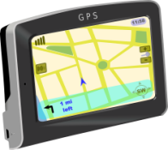 |  |  |  |  | 2  ...I get lost when I go alone to a place.
GPS smart sole/shoe. They can be programmed to operate a pedestrian route, vibrating if you are on the wrong track. |  |  |  |  |  |  | 3  ...If I need to know which activities I have to do today or this week.
APP. Daily schedule of activities to be used with your mobile phone. |  | 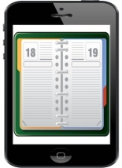 |  |  |  |  | 4  ...I need to weak up on time and have a better time orientation.
Speaking alarm clock. |  | 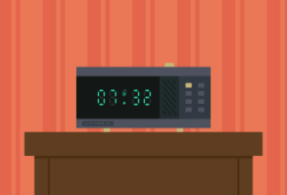 |  |  |  |  | 5  ...I would like to know how to get a place and let my family to know where I am.
 | Assistive technology |  |  |  | Match each product with its usefulness. |  |  | It could help me if...
 | APP Shopping list in your mobile phone.  It is available a version with pictograms. |  | 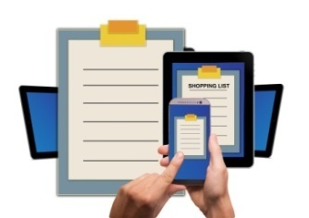 |  |  |  |  | 6  ... I forget the activities I have to do.
 | The use of the alarms of your mobile phone |  | 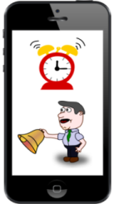 |  |  |  |  | 7  ... I don´t remember when I have to take the medication or which pills I have to take.
 | Mobile phone APP to help you to remember the medication taking. |  | 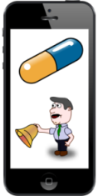 |  |  |  |  | 8  ... I forget how much time I have to be cooking a food item.
 | kitchen chronometer |  | 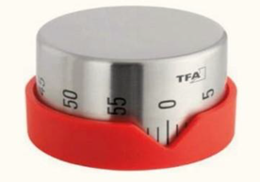 |  |  |  |  | 9  ... I need help to know when I have to do the shopping and where to find it in the supermarket.

