Exercise 2.4. Helping Maria to choose her support products.

Maria`s story
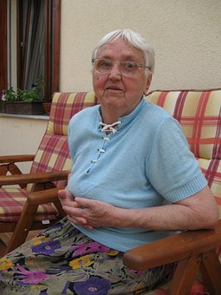

This is Maria, she is 57 years old, living alone with the help of her educator, who goes every day, 1 hour, to help her with some home activities.

Maria used to go every day to walk down around the neighbourhood, but she got lost a few times when coming back home, consequently, she is coming out each time less.

In addition, Maria fell down two months ago and she broke an arm and her right hip and she is not fully recovered since then.

Now, she easily gets tired and she is afraid of tripping over the pieces of furniture at home. Additionally, She has some difficulties to wash herself, to cook, to get dress alone, to take the medication and to walk safely.

Her educator has also realized that Maria forgets or doesn´t remember things some times. She has left the shower tap on and she has overcooked the food on occasion.

Finally, Maria is very scared to be forced to leave their home to live in a residence.

Activity 1. Helping Maria to choose their support products

It is proposed in this exercise to start a debate about which support products Maria should use to better do her activities of daily living and have more personal autonomy and quality of life.

Educator and AAWID can have a look at the photos and drawings of the next page, and discuss about their usability and decide which one of them could be used by Maria to get over her problems.

