Exercise 2.3. My support products.

Activity 1. Understanding what support products are.

This is an introductory exercise. The group will proceed to agree on a definition of support products. To this, it can be viewed the images of the 6 products on the right part of this page and ask to AAWID to cooperate to create a common definition of "support product". An example of definition might be: Support products are tools that let us to carry out the activities of the daily living in a more autonomous way, improving our quality of life". The following questions can facilitate the debate:

- Do support products help me to do more things at home? Which activities?
- Do support products help me to be happier?
- By using them, can I go to more places? Where? How?
- By using them, can I have more fun with my friends?
- By using them, can I do more activities far from home? Which? Why?

Activity 2. Personal autonomy: learning the fact I will need more supports in the future.

Once the participants have learnt what a support product is, a new one discussion can start to reflex about the fact that, as people get older, a higher number of support products are needed to keep the personal autonomy.

SUPPORT PRODUCTS

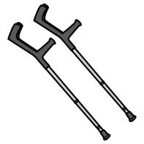
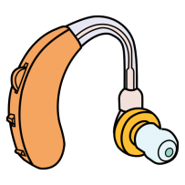

Activity 3. My support products and their appropriate maintenance.

Following, it can be asked AAWID to write -or verbally express- whether they use any support product.

Once it has been identified the support products that each AAWID uses, they will be invited to explain how the take care and clean them. To facilitate the activity, a debate using some of the following question might be carried out:

- Do you clean your support products?
- How often? Every day, once a week, once a month, when they are dirty, never...?
- Which cleaning product do you use? to clean them (glasses, hearing aids, wheelchair...? soap, specific products, water, with nothing?
- Do you take your support products to any place to get them checked? Yes/No. How often? Only when they break, once a year, when the shop assistance tells me to go?

To finish up this exercise, AAWID can fill out the following template, to practice how to monitor the cleaning frequency or maintenance of their support products.

Support product | Date | Date | Date | Date
Glasses

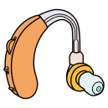
Hearing aids

Wheelchair
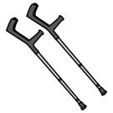
Crutches
Walker

Dental Prostheses
Others

Others

