Exercise 2.2. Adapted environments.

Activity 1. What an adapted environment is?

Firstly, with all participants, the concept of adapted environment will be discussed.

An adapted environment is the one that has been modified in order to improve the personal autonomy, reduced risks, to have a better social interaction and be able to take a higher number of decisions without the help of others. Some examples that might be used in the debate are: building a ramp, to change the bath for a shower, improve the home lighting, to put a light in the home phone, to remove or change the pieces of furniture that impede us to freely move or integrate new elements of assistive technology.

The photos and images that following appear are examples of 10 adapted and non adapted environments that might be showed to AAWID to facilitate de discussion.

Additionally, it can also be watched the following videos (Spanish subtitles) that show the different changes that can be done in a bathroom, kitchen and living room:

- Elderly people and bathroom changes. mp4
- Elderly people and kitchen changes. mp4
- Elderly people and living room changes.mp4

Example 1. Spacious dining room with a correct lighting where a wheelchair can manoeuvre on site and new pieces of furniture or technological equipment can be added, if needed.
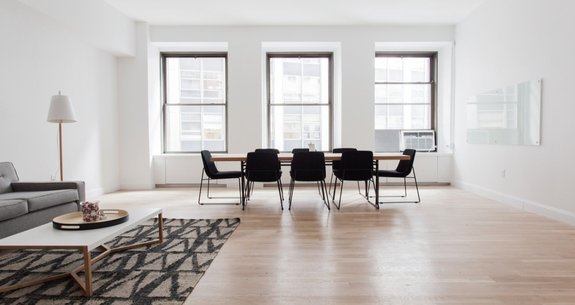

Example 2. Spacious flat with a correct lighting, no stairs and a proper number of pieces of furniture.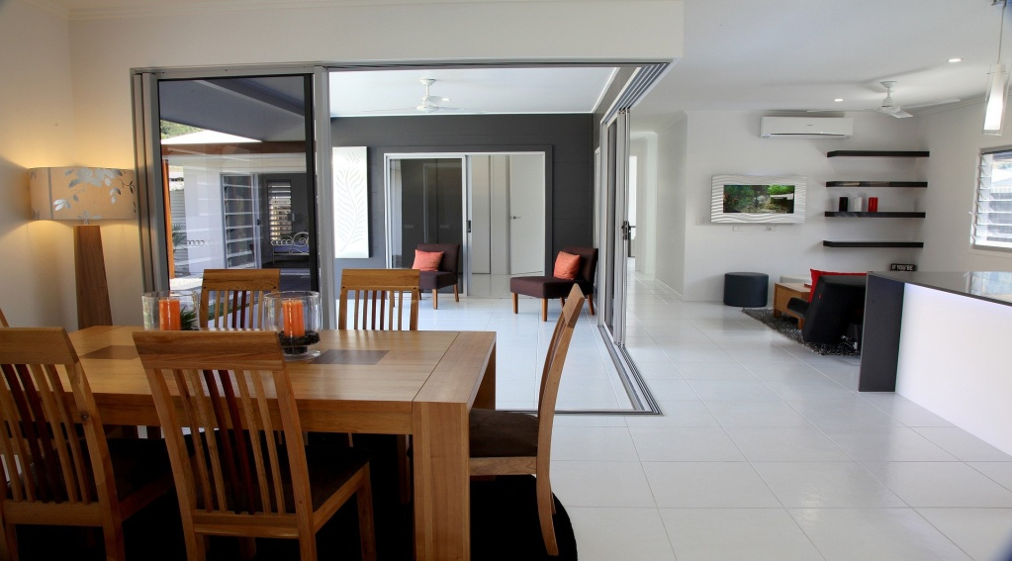
Example 3. Unadapted buildings, with difficult access, main entrance stairs, no ramps and several floors without a lift.
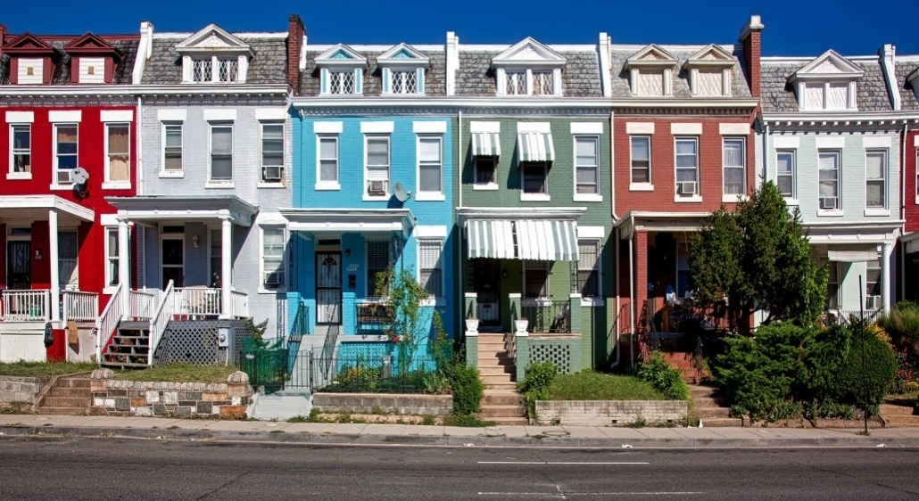

Example 4. Buildings with main entrance stairs and very steep hill.
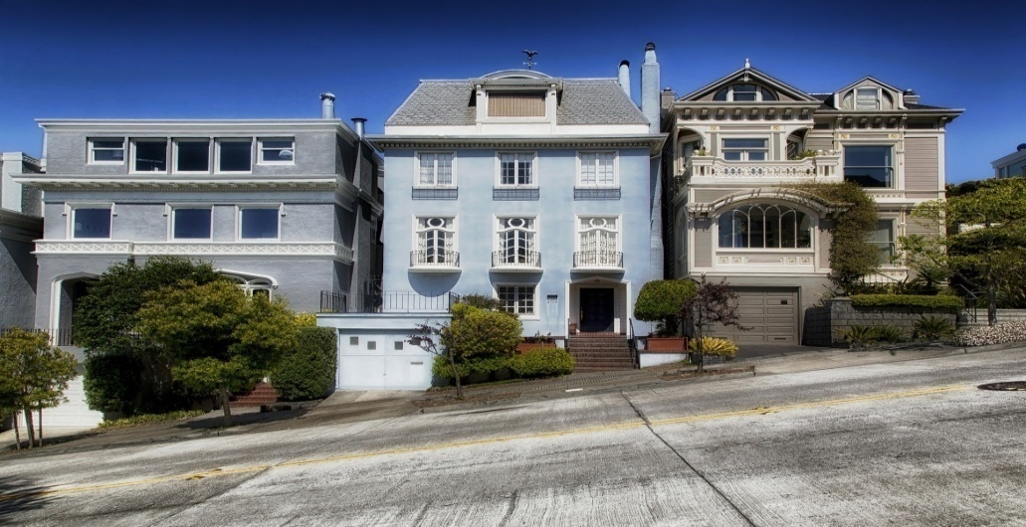

Example 5. Spacious bathroom with walk-in shower and proper lighting, but lacking of several adaptations (bars, shower seats, grab rails, assistant poles, non slip flooring, foldable or fixed seats...)
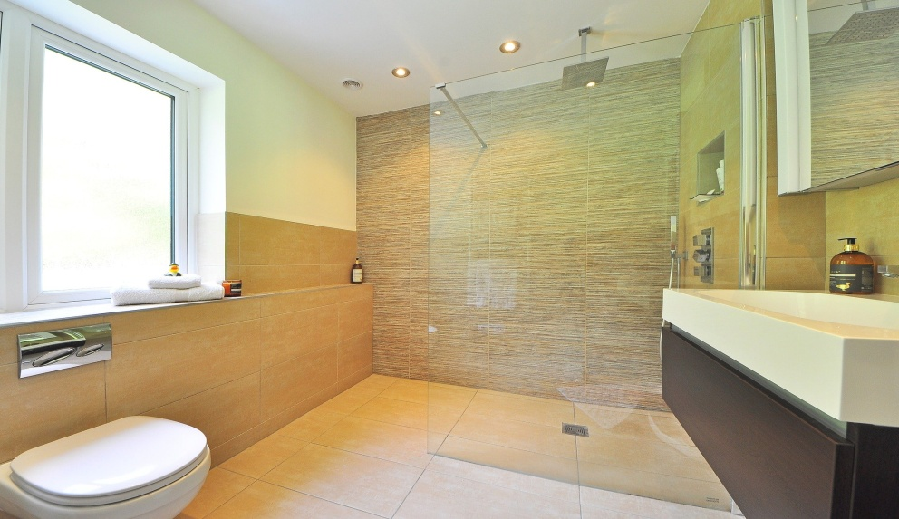

Example 6. Small unadapted bathroom with bath and very high cabinets difficult to reach.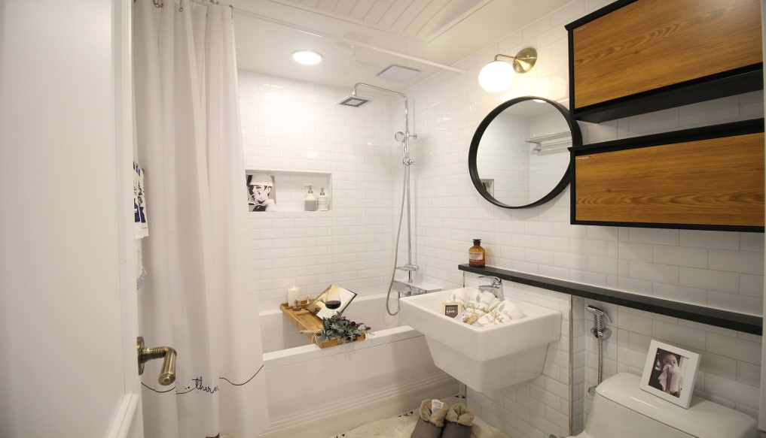

Example 7. Pictogram of bathroom fully adapted.
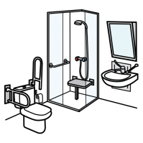

Example 8. Room poorly illuminated, with stairs and lacking of functional and accessible furniture.
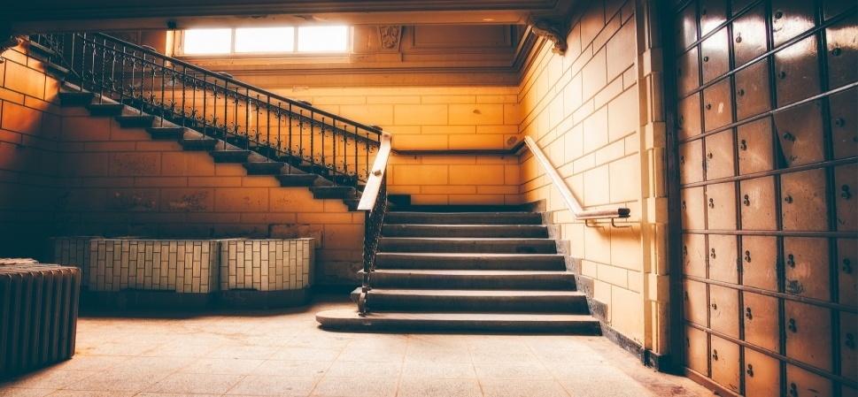
Example 9. Spacious kitchen, very functional and proper lighting.
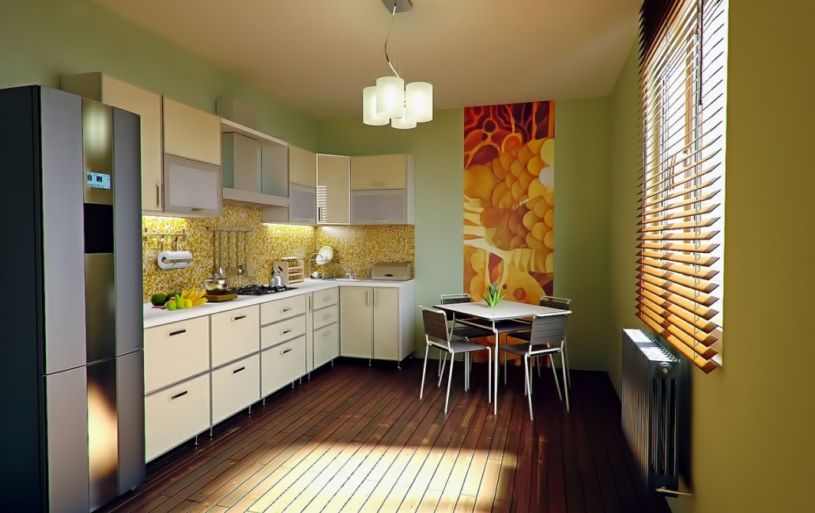

Example 10. Non-functional kitchens

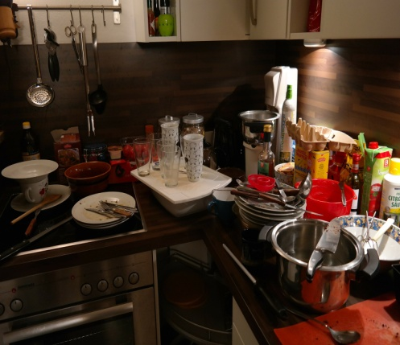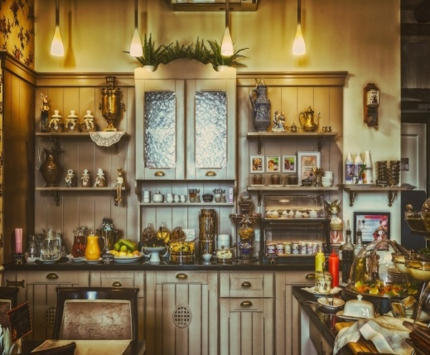

Activity 2. How can I adapt mi home to be safer?

In this exercise, AAWID will be invited to analyze if they need any change in his home (house, residence, shared apartment, etc.). It can be suggested to all participants to make photos of their homes to check, all together, whether some changes or improvements can be done in order to improve the personal autonomy. Days later, after the modifications, new photos can be taken to check the improvement obtained.

