Exercise 2.1. Difficulties in the activities of the daily living.

Activity 1. Identifying difficulties.

In this exercise, ageing adults with intellectual disability (AAWID) will start an active debate about whether they have any difficulty to carry out their activities of the daily living. The pictures on the right side of this page can be named, showed or commented to help AAWID to identify in which activity they might have dificulties.

Activity 2. To find resources and how to ask for help.

This is a local activity. Once indentified the most important difficulties, educator will teach AAWID where they can find the help to get over a given difficulty. Some local options might be to go to a known occupational therapist, to a nearby support products shop, or to a local or regional public institution to get advice or financing.

Additionally, it might be carried out a role playing to discuss:

- Where and how can appear new difficulties as we are getting older.
- Where and what we have to do to ask for help to get over a specific problem.

Food, eating and drinking | Personal hygiene and grooming
 | 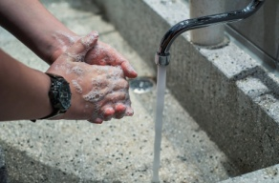
To get dress | Having a shower
To cook | Cleaning the house
To walk down the street | Use the money
Take the medication.

