Exercise 1. 4. Which residential option suits my
interests and needs best? (My future residence)

The educator presents the various residential options, as well as their advantages in terms of the Quality of Life Model. Ask each participant to say
what their chosen choice is and to explain their positive and negative feelings about the different residential options to the group.
The following two tables can be used as visual support.

Note: It is highly recommended that you have done the previous exercises of this unit to facilitate decision-making in this exercise.

A | B | C | D
I would prefer living in a  RESIDENCE FOR THE ELDERLY  because... | I would prefer living in a  RESIDENCE FOR PEOPLE WITH DISABILITIES  because... | I would prefer living in  MY OWN HOUSE  because... | I would prefer living in a  SHELTERED HOUSE  because...
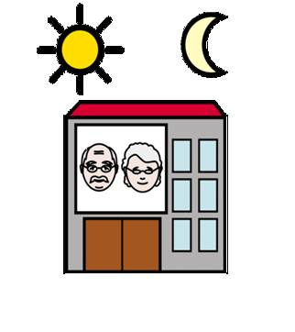 |  | 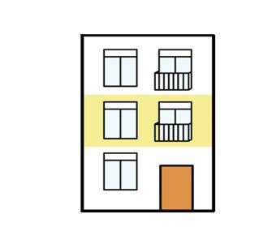

A | B | C | D
I would NOT like living in a  RESIDENCE FOR THE ELDERLY  because... | I would NOT like living in a  RESIDENCE FOR PEOPLE WITH DISABILITIES  because... | I would NOT like living in  MY OWN HOUSE  because... | I would NOT like living in a  SHELTERED HOUSE  because...

