Exercise 1.2. What should we take into account when deciding where we will live when we are older?

The educator establishes through a group discussion those issues which are important to decide in relation with one’s future residence, trying not to leave off the following issues specific to the Quality of Life Model:

- Independence, privacy...
- Rich environment (outdoor activities, access to community services, parks and gardens, art museums, transport networks...)
- Proximity to friends and family
- Activities of interest
Note: It is highly recommended to use visual support such as the one suggested in this page to compile each of the options mentioned and present them in a panel.
- Care
- Peers
- Accessibility to the building, home adaptations...

Privacy | Friends | Family | Care | Outdoor activities
 |  | 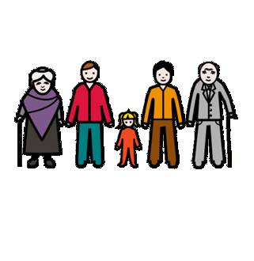 | 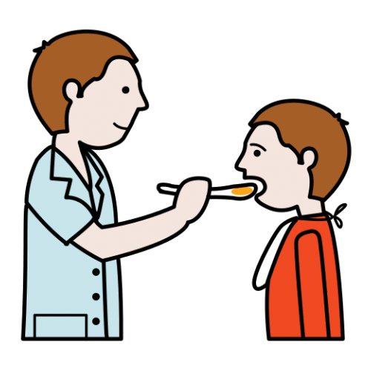 | 