Maria’s story...

Maria is 63 years old and lives alone in her house. She goes to the Occupational Centre every morning and enjoys the tasks she carries out at her workshop.

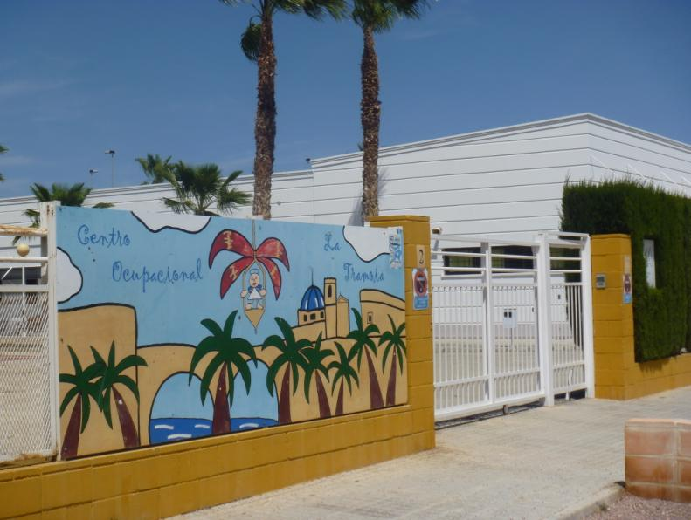

She has a lot of friends and gets along with the staff. She lives alone in herhome, where she receives support from Gloria, a home-help assistant who brings her food and supports her in some household chores.



Maria really likes her house, as well as maintaining her independence. She has recently noticed that she is having more difficultyclimbing stairs and performing certain tasks of the workshop that used to be easy for her.

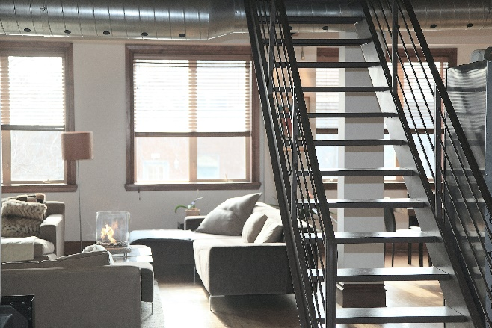

Philip, the psychologist at her centre, has explained to her thatshe will progressively have more and more difficulty performing her daily life activities and that it would be convenient to think about what the best residential solution for the future would be.



Maria has many doubts about what will be best for her....



Exercise 1.1.Moving to another place.

**Note:** The educator must keep in mind that for some people with intellectual disabilities, the concept of moving or adapting your home may be too abstract and they may have great difficulty with this exercise. In such cases, the educator should devote additional time and attention to thoroughly discuss the notion and the concept behind it.

Activity 1. What is the concept of moving to another place?

Ageing adults with intellectual disabilities (AAWID) and the educator should read the story. If needed, the trainer could use various techniques to support the AAWID in understanding the essence of the story. Then the AAWID is invited to answer the questions below, as the educator should encourage the aging person to explain in more detail each of his answers. The idea of this exercise is to allow the trainer to observe what is the AAWID level of understanding regarding the concept of moving to another place or/and residential options.

|  |
| --- |
| Why persons sometimes have to move from one home to another?………………………………………………………………………………………………………………………………..........................................................................................What about Maria´s situation? What might be her options?………………………………………………………………………………………………………………………………..........................................................................................What would you recommend to Maria? Should she move to a different home?……………………………………………………………………………………………………………………………….....................................................................................Do you know anyone that has recently moved to another place? Why?………………………………………………………………………………………………………………………………..........................................................................................Do my caregivers take into account my opinion in this issue? Can I refuse to move?……………………………………………………………………………………………………………………………….......................................................................................... |

Activity 2. Learning the different residential options

The educatoropens debate in the group so that each member can share the different residential options they knowfor old people.

|  |  |  |
| --- | --- | --- |
| **1**  **Residence for the elderly** | **2**  **Residence for people with disabilities** | **3**  **Own housing** |
|  |  |  |

**Note:**This exercise will vary according to the options in each country.

It is highly recommended to use visual support such as the one suggestedcompiling each of the options and present them in a panel. It is recommended to use photographs from the resources of each entity so that the AAWID are familiar with them (residences, supervised housing, etc.).